


Tree Management for Council Housing
Properties Policy Consultation Report

Contents
Aims of the consultation……………………………………….……….…3
Approach to the consultation…………………………………………..…3
Summary of consultation results………………………………………....4
Consultation questions and responses…………………………...….….5
Feedback from policy engagement session…………………….....…..11
Relevant actions to be taken……………………………………….……13

Aims of the consultation
It is important that we hear from as many people as possible who live and work in Sandwell every day when developing our policies.
This consultation was designed to gather feedback from residents, tenants, employees, and councillors on our Tree Works for Council Housing Properties Policy prior to its publication.
This policy outlines how and when tree works will be carried out on council housing properties, including the management, maintenance, and safety measures involved. It explains the process for reporting concerns, requesting works, and how the Council will prioritise and respond to tree-related issues.
Feedback received during this consultation will help shape the final version of the Tree Works for Council Housing Properties Policy.
Approach to the Consultation
Policy Engagement Session
The Tree Works for Council Housing Properties Policy was shared with residents during a policy engagement session. Residents provided feedback on the proposed approach to tree management, the clarity and accessibility of the document, and any areas they felt were missing or needed improvement.
Please note that the analysis of feedback in this report relates specifically to survey responses collected during the online public consultation. The final section of this report, along with the following table, also summarises feedback received from the resident engagement session.
Safer Neighbourhoods and Active Communities (SNAC) Board
The Tree Works for Council Housing Properties Policy was shared with members of the SNAC Policy Working Group and elected members to gather additional feedback and scrutiny.
Online Consultation
The online consultation ran from 28th August to 26th September 2025. The survey included both qualitative and quantitative questions, allowing respondents to provide feedback on the proposed tree management approach and assess the accessibility of the policy document. Feedback received will be used to revise the policy as necessary before it is finalised and presented to Cabinet for approval.
Summary of consultation results
The consultation findings indicate mixed views on the Tree Works for Council Housing Properties Policy, with just over half of respondents supporting its aims. Those in favour welcomed the Council’s commitment to maintaining safe, well-managed green spaces, while some noted that the policy felt aspirational and would benefit from clearer examples and more detail on how tree works will be implemented.
Opinions were also mixed on whether the policy clearly explains how tree management and maintenance will be carried out. While some respondents appreciated the broad overview of planned works, others felt it lacked practical guidance on how to report issues, request specific works, and what steps would follow. Several respondents highlighted the need for clearer timelines and points of contact for queries.
Most respondents felt the policy would be understandable to residents, praising its structure and accessible language. However, some suggested that certain sections could still be complex, recommending additional support such as simplified guides, visual aids, or illustrative diagrams.
Overall, there was a sense that the policy is well-intentioned and, with some refinement, will effectively support the needs of residents and ensure safe, well-managed trees on Council housing properties.

Consultation questions and responses
This policy had 11 responses.
Please tick which best describes your interest in this consultation.
6 (55%) respondents were interested in this consultation as a tenant living in socially rented accommodation.
2 (18%) respondents were interested in this consultation as a member of a voluntary or community partner organisation.
2 (18%) respondents were interested in this consultation as a private rented tenant or person living rent free.
1 (9%) respondent was interested in this consultation as a homeowner.
Please state which type of accommodation you live in.
5 (45%) respondents live in a house.
5 (45%) respondents live in a flat.
1 (9%) respondent lives in a bungalow.
Please state your age group.
4 (36%) respondents were aged 60-64.
3 (27%) respondents were aged 25-35.
3 (27%) respondents were aged 35-59.
1 (9%) respondent was aged 65 and over.
What is your gender?
7 (64%) respondents were female.
4 (36%) respondents were male.
What best describes your ethnicity?
6 (55%) respondents were English, Welsh, Scottish, Northern Irish or British.
2 (18%) respondents were White and Black Caribbean.
2 (18%) respondents were Indian.
1 (9%) respondent was Bangladeshi.
For all questions, respondents could select one of the following answers:
- Strongly agree
- Somewhat agree
- Neither agree nor disagree
- Somewhat disagree
- Strongly disagree

- Before reading this policy, I was aware of the services Sandwell Council provide in support tree management.
Before reading this policy, respondents were asked if they were aware of the tree management and maintenance services Sandwell Council provides for council housing properties.
The slight majority of respondents, 6 of 11 (55%), stated that they were aware of these services. Three respondents neither agreed nor disagreed, and two respondents strongly disagreed.
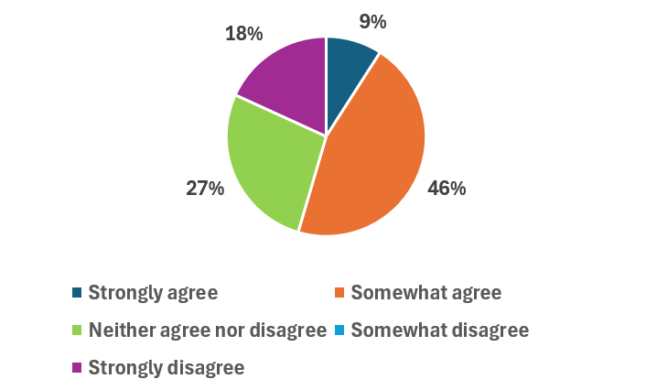

- To what extent do you agree or disagree with the purpose of the Tree Works Policy?

A slight majority of respondents, 6 of 11 (55%), agreed with the aims of the Tree Works for Council Housing Properties Policy.

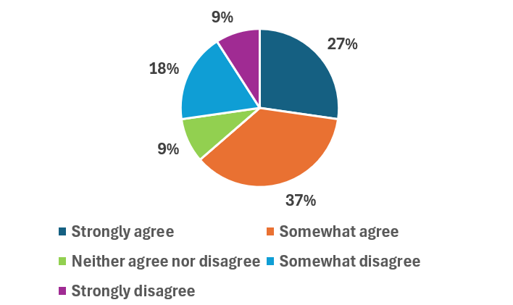
Those in agreement felt that “the policy’s intent to ensure safe, well-maintained trees on council housing properties is important and well thought-out”, and that “it gives a helpful overview of how the council manages tree works”. Another respondent commented that the council’s commitment to “ensuring safety and protecting green spaces is crucial”. One respondent added that “it is important that all residents feel confident their needs around tree works will be met”.
However, those who agreed also suggested that “some of the language feels aspirational”, and that “the policy could be strengthened by including clearer practical details”. They recommended “adding specific examples of tree works and outlining the steps residents can expect when reporting an issue”.
Three respondents disagreed with the aims of the Tree Works Policy, though they did not provide reasons.
- Are the tree works responsibilities for tenants, leaseholders and the council outlined in this policy easy to understand?
Five respondents (45%) agreed with the clarity of the Tree Works for Council Housing Properties Policy, while three respondents (27%) disagreed and three respondents (27%) neither agreed nor disagreed.
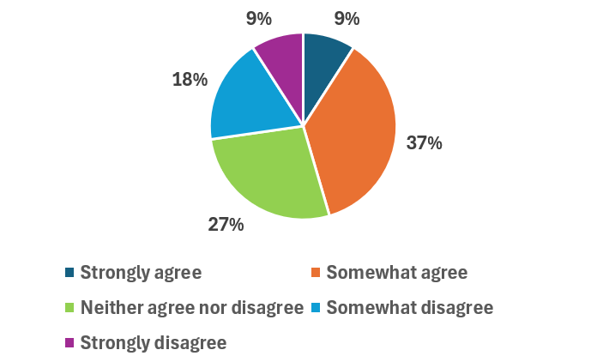
Those who agreed felt that “the policy covers tree management in broad terms” and that “it sets out the main ways the council will support residents by maintaining trees on housing properties”. However, they also suggested improvements, including “clearer instructions on how residents can report tree concerns, what happens after a request is made, and what they can expect during the process”. They also recommended “including more detail on timelines, points of contact, and escalation routes to reassure residents their concerns will be addressed effectively”.
One respondent who neither agreed nor disagreed commented that “the policy could do with a few tweaks to make it plainer”. A respondent who disagreed explained that “certain sections feel vague about what will actually be delivered, making it difficult for residents to know what to expect”. They added that there is a need for “more detailed information on how tree works will be carried out in practice and how residents can engage with the council to request them”.

- Does the policy clearly explain how and when tenants should issues related to trees?
8 of 11 respondents (73%) agreed that the majority of residents will understand the policy. Just 1 respondent (9%) disagreed.
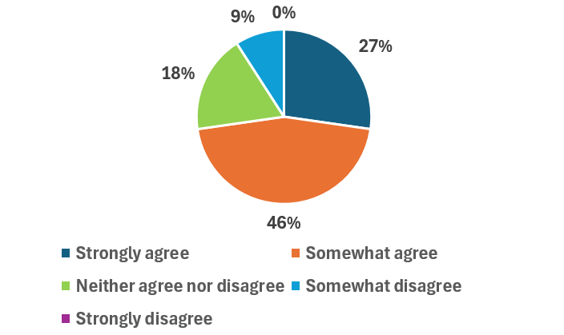
Those who agreed felt that “the majority of residents should find the policy straightforward because of its clear structure and use of simple language in key sections”. However, they also noted that the policy “may still be too detailed for some residents to fully understand without additional support such as workshops, guidance notes, or visual aids”.
One respondent who agreed added that “the policy is mostly understandable for many residents, but some might still need assistance or further explanation, particularly around processes and procedural steps”.
One respondent who neither agreed nor disagreed suggested that “different methods of communication may be needed to ensure all residents can access and understand the information”.

5.) Any other comments

When asked for additional comments on the policy, respondents said:
- “The policy is structured logically and uses straightforward language, making it easy for most residents to follow and understand how tree works will be managed.”
- “The intentions of the policy are commendable, and with continued refinement, it will better meet residents’ needs.”
- “The language and structure are mostly clear, but occasional technical terms or complex sentences could be simplified to support full understanding.”
- “The council’s efforts to clarify how tree management will be handled are appreciated; ongoing review will help ensure clarity and accessibility for all residents.”

Feedback from policy engagement session
The feedback presented below was provided by residents of Sandwell during a policy engagement session.
1. Before reading the policy, were you aware of Sandwell Council’s tree management and maintenance services for housing properties?
- Awareness was mixed—some residents were aware, while others were not.
- Those who were familiar often had direct experience of tree works being carried out or knew someone who had reported a concern.
- Residents stressed the importance of raising awareness of the service. Suggested methods included the Sandwell Herald, noticeboards in communal areas, libraries, and other community spaces.
- Some residents asked how much flexibility there is for residents to influence or shape the policy.
2. Does the policy make it clear how Sandwell Council will support residents through tree works?
- Residents felt the policy explains what should happen but lacks clarity on how it will work in practice.
- Questions were raised about how outcomes would be tracked and communicated to residents.
- Many felt the policy needs to be promoted more widely and in more accessible ways.
- Suggestions included:
  - Adding a dedicated section or tile on the MySandwell dashboard.
  - Using infographics to explain processes and improve visibility.
  - Strengthening partnerships with professionals such as arborists and environmental officers to streamline responses.
  - Holding regular surgeries with housing officers to increase engagement.
- Some residents commented that terms such as “priority” or “essential works” could be open to interpretation and need clearer definitions.
- Residents also recommended grouping examples of tree works in a clear, easy-to-read format using simple language.
3. Is there any information missing from this policy document regarding tree works that should be included?
- Most felt the core information was present, but said the policy would benefit from improvements in clarity and accessibility.
- Residents wanted more real-life examples of the types of tree works that might be carried out, such as pruning for safety, removal of dead trees, or managing overgrown trees that block light, damage property, or affect access.
- The language of the policy was felt to be too technical in places and should be simplified to make it easier for all residents to understand.
- Suggestions for further promotion included WhatsApp groups, local newsletters, noticeboards, and councillor or MP surgeries.
- Infographics and digital tools, such as a MySandwell tile, were also suggested to help residents with different accessibility needs.

Actions taken in response to consultation feedback
During the consultation, respondents were given the opportunity to elaborate on the reasoning behind their answers to the multiple choice questions. Question 5 also asked for any additional feedback on the policy not otherwise stated. Feedback received from respondents can be found in the table below, in addition to our response and any actions we are taking.
What respondents told us | Our Response | Relevant Actions | Timescale
While the policy outlines broad intentions, it lacks specific guidance on how tree works will be delivered in practice, including timelines and responsible contacts. | Sandwell Council acknowledge the need for clearer operational guidance and commit to making the policy more actionable. | Establish and communicate a clear process for reporting tree concerns and carrying out works, specifying response times and identifying responsible contacts. | October 2025
To raise awareness of the policy, it could be promoted in the Sandwell Herald, on local noticeboards, in libraries, community spaces, WhatsApp groups, and at council surgeries. | The Council agree that wider promotion is essential to improve accessibility and awareness. | Develop and implement a communications plan that uses local and digital channels to explain how tree works are managed. Link this to resident engagement within the Tenant Engagement Strategy. | December 2025
Visual tools, infographics, and guides could make the policy more accessible and resident-friendly. Plain English should always be used. | The Council will revise the policy using plain English and develop supporting visual materials. | Produce infographics and Easy Read versions of the policy. Conduct a plain English review. | December 2025
Examples of the types of tree works that might be carried out should be included in the policy. | Including real-world examples will make the policy more practical and relatable. | Add a section with examples such as pruning for safety, removing dead or dangerous trees, and managing overgrown trees that affect light, access, or property. | October 2025
Terms such as “priority works” or “essential works” are open to interpretation and need clearer definitions. | We recognise this ambiguity and will provide clearer definitions aligned with best practice and operational standards. | Define “priority works” and “essential works” within the policy, with reference to arboricultural guidance and practical considerations. | October 2025

