



**Mobility Scooter Policy - Consultation Report**

Contents

Aims of the consultation 3

Approach to the consultation 3

Consultation Questions and Responses 4

Action taken in response to consultation feedback 13

# 

# Aims of the consultation:

We wanted to obtain feedback about our Mobility Scooter Policy, which is currently being revised. Mobility scooters have become an increasingly popular mode of transportation for individuals with disabilities or mobility issues – this is apparent in Sandwell, where the proportion of residents identifying as disabled is 20% (as compared to 17.8% in England and Wales).

As the use of these mobility vehicles grows, so do the concerns regarding their safe storage and use in communal areas in council accommodation. These concerns include fire safety, trip hazards and building damage. Therefore, there is a need to monitor mobility scooter usage to protect and preserve the health and safety of all residents living within our accommodation, as well as visitors and our staff.

The intended aims of our Mobility Scooter Policy include:

* Ensuring every tenant or leaseholder should notify Sandwell Council of their possession of a mobility scooter so that a record of this will be kept.
* Introducing a management scheme to ensure that mobility scooters are maintained, stored and charged safely.
* Issuing advice for tenants regarding the purchase of suitable mobility scooters and awareness of the health and safety risks associated with their safe storage.

This consultation has sought to work with Sandwell residents to make the best possible decisions to increase the safe use and storage of mobility scooters. The resident feedback received will assist us in developing a policy that works well for all our customers.

# Approach to the consultation:

A 9-week consultation period took place from **25 July 2024** to **27 September 2024**. Residents were able to respond to the consultation via online survey (on the Citizen Space platform). However, paper copies of the survey were provided to those who requested them. Our strategic approach to the survey sample meant that this questionnaire was particularly aimed at capturing the views of the following:

* Mobility scooter users in socially rented accommodation, especially low or high-rise flats,
* Neighbouring residents of these low or high-rise flats,
* Elected members from the Sandwell Borough.

Posters giving details of the consultation were displayed in the public areas of certain high-rise and low-rise blocks.

Other views this survey was interested in capturing included feedback from Sandwell’s elected members., who were all emailed a copy of the draft consultation.

In total, we received **18** responses to the consultation – 17 of these responses were received online and 1 over the phone.

# Consultation Questions and Responses

**About you:**

As of **30 September 2024**, this survey had **18** responses overall (17 online and one by phone).

1. **Please tick which best describes your interest in this consultation:**

Of the respondents:

* 56% (10) identified as a tenant living in socially rented accommodation
* 22% (4) identified as a homeowner
* 11% (2) identified as a member of a voluntary or community partner organisation
* 5.5% (1) identified as a private rented tenant/person living rent free
* 5.5% (1) did not answer.

1. **Are you a mobility scooter user or do you live with someone who is?**

Of the 18 respondents to this consultation, 50% (9) did not use a mobility scooter or live with someone who did. However, 44% (8) did use a scooter or live with a mobility scooter user. 5.5% (1) of respondents preferred not to say.

1. **Please state which type of accommodation you live:**

The majority of respondents to the consultation lived in a flat, with 56% (10) selecting this option. 33% (6) of respondents lived in a house and 5.5% (1) living in an apartment. 5.5% (1) did not answer the question.

1. **Please state your age group.**

33% (6) of respondents were aged 35-59, 17% (3) were aged 60-64 and 44.5% (8) were 65 and over. 5.5% (1) did not answer the question.

1. **What is your gender?**

50% (9) of the respondents to this survey identified as male. The remaining 50% (9) identified as female.

1. **What best describes your ethnicity?**

56% (10) described themselves as ‘English, Welsh, Scottish or Northern Irish’ – the majority of respondents. 22% (4) described themselves as ‘Caribbean’ and 16.5% (3) as ‘Other White.’ 5.5% (1) did not provide an answer.

1. **Do you consider yourself to have a disability or long-term health condition?**

Of the 18 respondents to this survey, only 5.5% (1) did not consider themselves to have a disability or long-term health condition. The remaining 94.5% (17) felt that they did have a disability or long-term health condition.

**Overall vision:**

1. **To what extent do you agree or disagree with the Mobility Scooter Policy’s overall vision?**

Responses to the Mobility Scooter Policy’s overall vision are largely favourable, with 78% (14) agreeing with the overall vision of the plan.

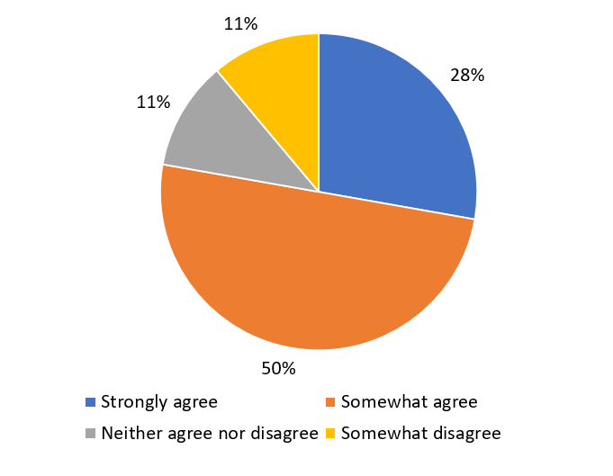

Additional comments showed that the common reasons for this support, i.e., “it makes sense to ensure that the charging of mobility scooters is safe, wherever they are charged, for the owners and other occupants of a common building.” Another stated ‘procedures and guidelines… will help to mitigate potential hazards or harm to individuals and to the environment as well as building resources in Sandwell”, adding that “it will also educate people who don’t have a mobility scooter on what to expect.”

However, some residents disagreed with this policy, arguing it to be too narrow in focus – “It feels as if disabled people living in flats are being singled out and discriminated against.” Another one that was in favour of the policy overall expressed some reservations about the reach of the document: “My concern here is that other e-Scooters are not covered in the scope of this policy.”

Other concerns mentioned were the costs of extra tests, for example, PAT testing – one respondent felt that is would be “very helpful if the council could carry out the PAT test at a minimal cost which would encourage more to book.” Another added “support those who need to arrange PAT testing, [don’t] just leave it to them. Not everyone has family to arrange this and could be feeling extremely anxious since receiving this.”

At least one resident seems to have misinterpreted the purpose of the consultation, mentioning the impact of a potential ban of e-Scooters.

**Policy aims:**

1. **Overall, to what extent do you agree or disagree with this policy aim of the document? - *“To promote the use and safe storage of mobility scooters and provide a clear statement on the management of mobility scooter storage and use within the council’s communal spaces.”***

Responses to this question were largely favourable, with 78% (14) of respondents choosing ‘strongly agree’ or ‘somewhat agree.’

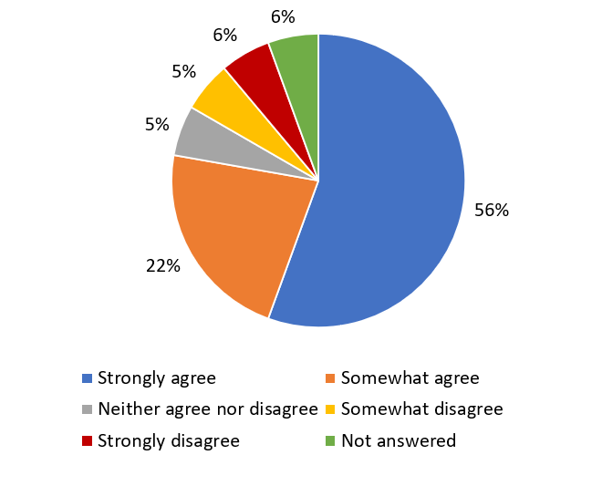

The given reasons for this support included tenant safety (i.e., “[the policy addresses] obvious concerns such as [scooters] blocking or making a quick exit difficult”) and making sure the tenants are aware of their obligations regarding mobility scooters, i.e., “to ensure that those who are in charge of a scooter are fully aware of their responsibilities.”

Despite the favourable feedback in response to these listed outcomes, some tenants do not believe that the proposed policy goes far enough, with some residents feeling that mobility scooters shouldn’t be kept in communal areas at all – “the aim is good, I believe that storage of property should be contained within your flat.” Others felt that there should be stricter rules around charging, i.e., “charging should only be allowed in the person’s own home and stipulation that charging should only be done under supervision of the scooter owner, i.e., not a night while asleep but only when anything goes wrong would be spotted quickly.”

As with the overall vision, some residents expressed concerns about the limited focus of this policy – “you have singled disabled people to be monitored, that’s not fair” or “the policy to only those with a mobility scooter - other e-Scooters are still prone to being combustible like any battery-powered vehicle.”

1. ***When asked whether they agreed with the following policy aims: “To protect and preserve the health and safety of all residents living within our accommodation, as well as staff and visitors.”***

Whilst a small cohort of respondents disagreed with the outcome being proposed here, responses were still predominantly favourable, with 78% of respondents agreeing.

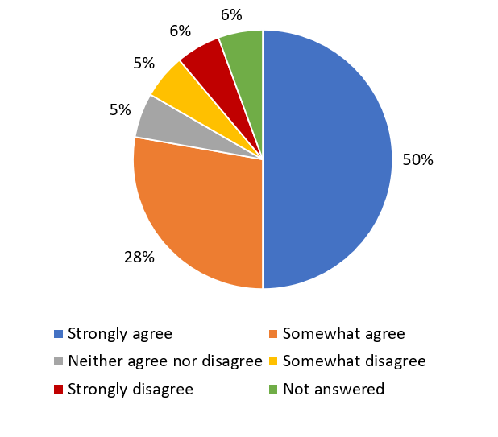

Comments supporting this outcome included “I think that all residents need to have the space to move around their homes safely and not have mobility scooters preventing them from doing so”, with another agreeing ‘it addresses health and safety issues for all residents and staff.” Although some respondents strongly agree with this aim, they feel that it could go further, with the council doing more to make the potential issues with mobility scooters clear, i.e., “It’s an obvious safety issue and the council needs to stipulate this before allowing ownership so that if this rule is ignored, the council can quickly enforce this rule.”

However, in addition to the recurring comments about e-Scooters, there were also concerns about a ‘Nanny State mentality”, suggesting that certain residents are worried about potential limitations on their freedom.

1. ***When asked whether they agreed with the following criteria: “To ensure all new and existing tenants are aware before they purchase or lease a mobility scooter, they must seek permission from the council to ensure there is adequate storage and charging facilities available.”***

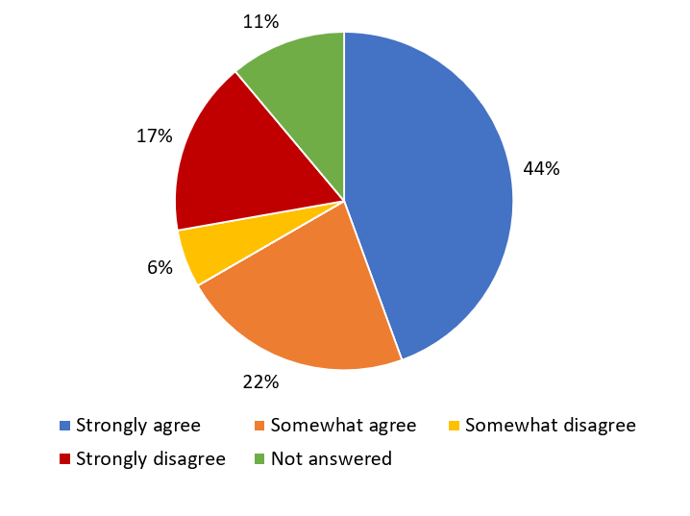

Although the majority of respondents (66%) agreed with this policy aim, the rate of agreeance was down slightly from the previous questions. Those agreeing with the aim mentioned that it might “help the individual to make informed choice[s]”, with another respondent adding ‘this action of permitting mobility scooters should be fair in its management. Alternative arrangements or accommodation should be discussed if their current accommodation is inadequate.”

However, 17% of those surveyed disagreed with this policy aim. Some doubt the practicality of the aim, i.e., “this isn’t always a possibility as disability sometimes happens quickly and the process with the council is never a quick one.” Others feel, if denied permission, this would preclude them from moving into council flats or else from getting out and about easily – “Nobody should have to get permission in order to be able to access the local community.”

1. ***When asked whether they agreed with the following criteria: “To encourage all residents to purchase adequate scooter insurance, arrange annual Portable Appliance Testing (PAT) for their scooter and keep theirs in good working order, as well as making tenants aware of their responsibilities with regard to storage and use of mobility scooters.”***

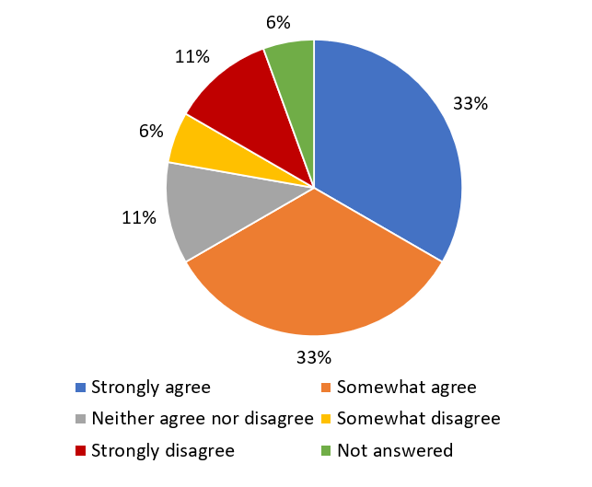

Overall, there was a positive reaction, with 66% of respondents agreeing to this aim. Many respondents have mentioned the overall benefit to the owner/user of the scooter – “insurance is important to ensure that the user is covered in the event of malfunction of the scooter” or “responsible owners would do this anyway as the scooter is key to independence.” One resident wanted the policy to go further, stating “electric compliance should and must be in place.”

However, some respondents were worried about the costs of this, with one suggesting that this should not be a legal requirement – “Not everyone could budget for a mandatory service at a specific time every year and the frequency of servicing would vary upon the amount of use a scooter gets.” Another added that “the council should at least provide PAT tests (even if there is a charge)”, fearing that “elderly and/or neurodivergent people might struggle with this.” Others doubt the necessity of PAT testing at all, i.e., “nowhere when purchasing scooters have I ever seen annual PAT testing advised by any manufacturers.”

One resident, although agreeing with the overall aim, does not feel that the policy has properly addressed the issue – “I think this is a great aspect of the policy but reading the policy, it didn’t seem to have a robust process for checking that insurance is continuously in place.” They suggest that the council should, at least, signpost scooter users to nearby PAT testing centres, as well as advising that this should be made available in several different languages.

1. ***When asked whether they agreed with the following criteria: “To make tenants aware of their responsibilities with regard to storage and use of mobility scooters.”***

There was a very positive response overall to this question, with 77% of respondents agreeing with the aim.

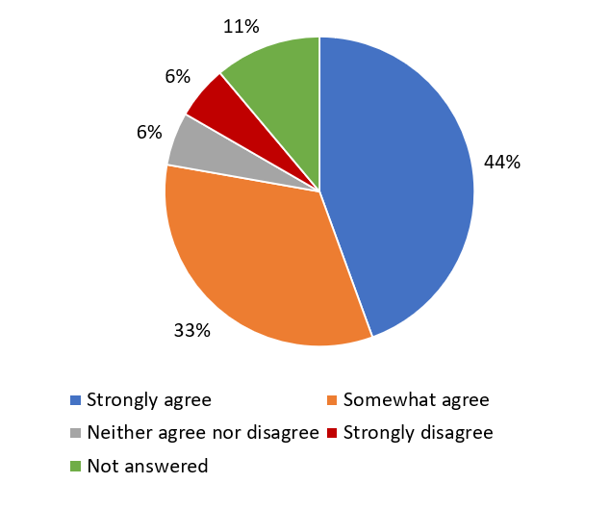

The reasons given for this agreeance were usually about the safety of the other tenants, including the “need to prevent careless storage where a scooter would make other tenants’ ability to enter and leave the communal areas harder.” Some respondents, although agreeing overall, wondered how the council would go about increasing awareness, suggesting Twitter (X), SAFL, and outreach events at local stores and educational services.

However, some respondents were worried about the effects of this on mobility scooter users, one commenting “it’s a lot to put on some people, all they are doing is trying to maintain some quality of life.”

1. ***When asked whether they agreed with the following criteria: “To ensure mobility scooter owners are aware that they will be held liable for any injury to other people or damage caused to the building or communal area as a result of incorrect storage or use of their scooter and will be recharged for any damage.”***

There was a very positive response overall to this question, with 67% of respondents agreeing with the aim. Some felt that this would hold certain scooter users to a higher standard of accountability, one respondent stating “if people know they are being held responsible for their scooters, they will think twice about where they store their scooters.” Another suggested sharing “near misses [and] lessons learnt” with residents.

Others felt that it should depend on the circumstance (“there should be a degree of flexibility for means beyond your control”), while one respondent thought that, if this were to be implemented, the council should bear part of the cost.

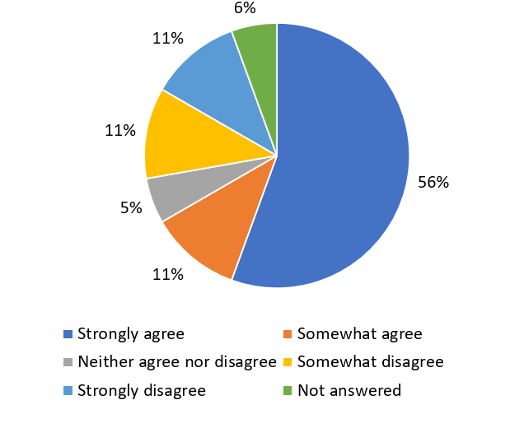

There were some that felt that this aim was unfair on mobility scooter users. Comments included financial reasons – “This should be covered by the council tax we pay and buildings insurance.” Another wondered “if you take all precautions, but it malfunctions why are we responsible for this? This is absolute persecution.”

1. **Are there any things you think are missing from the Mobility Scooter Policy and, if so, what are they?**

Overall, the response to the plan was favourable, being labelled as “comprehensive” and “appropriate.”

However, some residents expressed their reservations, with one resident wondering what the council was going to do about providing safe places for mobility scooters to be kept at or near residents’ homes or for when they are out in the community.

Others felt that the policy would be more inclusive if the council had made more effort to speak to mobility scooter users before drafting the policy. Another warned that the council may be seen as “discriminatory against disabled people” if there is not also an upcoming policy on e-Scooters, with another resident mentioning the dangerous riding of electric bikes and scooters.

Some wanted the council to appreciate the differences between gel batteries and lithium batteries in the consultation, whilst others felt more “understanding of the difference between mobility scooters and electric wheelchairs” was needed in the policy.

One mobility scooter user drew attention to the difficulties they had getting around the borough due to poor parking – this included the inappropriate parking of council vans on the pavement.

Once again, some residents seem to have misunderstood the policy to be the precursor to a ban on mobility scooters, wanting “reassurance that community areas will not be restricted and that the council will allow [their] continued use.” This might reflect the mistrust another resident mentioned, stating that older people do not engage with the council because they do not trust us, viewing this policy as picking on easy targets. She suggested what the council needs to do is provide opportunities for in-person feedback and education of residents on the risks posed by the inappropriate keeping of mobility scooters.

1. **What more would you like Sandwell Council to do as an organisation to deliver housing in the Borough?**

Although some residents were clearly satisfied with the council (“I think you already do the best you can with limited funds available due to cuts in national funding to local councils”), there were a number of concerns raised when it comes to future housing-related matters in the borough. These included:

* Methods of communication, especially with those who are not IT literate – “the use of QR codes to access can be intimidating for some tenants.”
* The lack of EV charging points in council accommodation – “I understand all new builds are required to have a charging point fitted, unfortunately I live in a block of flats and have no method to charge overnight when it’s cheapest to do so.”

# Actions taken in response to consultation feedback:

* The feedback from respondents has made it clear that residents wanted a consultation on other electric vehicles, including e-Scooters. Our intention to launch this should be made clear to reduce any feelings of discrimination or victimisation.
* The council should make every effort to engage with mobility scooter owners/users, assisting them in finding appropriate PAT testing.
* Some residents feel that more engagement on this topic would be suitable, both in person and on our social media pages.
* From certain responses, it is apparent that there is some misapprehension around the consultation, with some users feeling targeted. On the back of this, the council should make more effort to engage with this group, providing opportunities for in-person feedback, as well as providing more education on the risks posed by inappropriate keeping of mobility scooters.