Housing Needs Assessment 2025

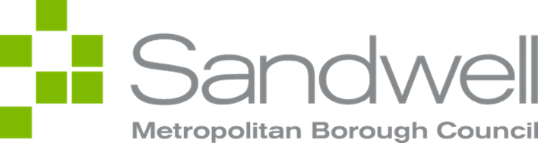

Document title | Housing Needs Assessment 2025
Owner | Louis Bebb, Housing Policy and Strategy Officer
Approved by
Status | Draft | Version | 2.0
Effective from | November 2025 | Approved on
Last updated | 11/11/2025 | Last updated by | Louis Bebb
Review date | November 2027
Purpose | The purpose of this policy is to set out Sandwell Council’s position on the provision and management of council-owned housing, including the types, tenure, and distribution of homes required to meet the current and projected housing needs of residents across the borough.

Section | Page
Executive Summary | 4
The National and Regional Picture | 6
Overview of Sandwell | 7
• Geography | 7
• Population | 7
• Health | 9
• Deprivation | 9
• Fuel Poverty | 9
Sandwell’s Housing Market | 10
• House Prices, the Rental Market, and Local Housing Allowance in Sandwell | 10
• Properties and Households in Sandwell | 10
• Council Stock Profile | 13
• Council Stock by Town | 13
• Housing Associations | 14
• The Impact of Right to Buy | 15
Sandwell’s Future Social Housing Stock | 16
• Future Housing Stock | 16
• Future Housing Developments in Sandwell | 17
Housing Needs for Sandwell’s General Population | 18
• Housing Register Overview | 18
• Bidding Activity | 21
Housing Needs for Specific Groups in Sandwell | 23
• Disabled Households | 23
• Older People | 25
• General/Adapted Living | 26
• Supported Living for Adults with Learning Difficulties and Autism | 27
• Accommodation Needs for Young People | 28
• Care Experienced Young People | 28
• Housing Needs for Ethnicity Groups | 29
• Migrants, Asylum Seekers and Refugees | 30
• Gypsy, Roma and Traveller Communities Residing in Permanent Dwellings | 34
References | 36
Appendices | 39

Housing Needs Assessment 2025
Executive Summary and Overview of Report
The Housing Needs Assessment outlines the current housing demands within the borough and predicts future housing requirements based on both local and national data. This 2025 document expands upon the 2022 version, incorporating the latest data and updated housing need projections through to 2041.
The Housing Needs Assessment provides an outline of the housing register as of March 2025, presenting the household composition of those on the register, their ethnicity, age and priority banding. An outline of the housing stock presents the proportion of the stock by area, bedroom number, and property type.
The Housing Needs Assessment also provides a summary of current and future housing need in the borough for specific groups.
It is vital that local authorities have a comprehensive understanding of their local housing market, and a robust evidence base on which to make informed decisions about future housing provision.
Overview of Sandwell’s Population and Demographics
Sandwell, a metropolitan borough in the West Midlands, consists of six towns and 24 wards. Sandwell has a strong industrial heritage as part of the Black Country and has major road and rail links with Birmingham and the wider West Midlands.
Sandwell’s population reached 341,900 in 2021, growing by 11%, outpacing national trends. Sandwell has a young and diverse population, with over 40% of residents under 30 and 42.7% from global majority backgrounds.
Life expectancy remains below the national average, with 60.2% of residents reporting long-term health conditions lasting more than 12 months.
Sandwell is the 19th most deprived local authority in England, with low employment (67.4%) and high economic inactivity (28.5%). Universal Credit claimants (6%) and youth unemployment (7.7%) are significantly above national averages.
Sandwell has a significant level of fuel poverty. The Fuel Poverty Risk Index ranks Sandwell as the 6th highest risk area for fuel poverty, across all local authorities in England. 20.8% of residents in Sandwell are in fuel poverty. This compares to 13.2% across England.
Overview of Sandwell’s Housing Market
Sandwell’s housing market has evolved over the past decade, with the private rental market expanding, and the local authority sector continuing to shrink. Despite a decrease in the social housing stock, Sandwell still has a higher proportion of social rented properties compared to the rest of the Black Country and England & Wales. The total number of properties in the borough grew by 6% between 2011 and 2021, a lower increase than that observed both regionally and nationally.
The average house price in Sandwell was £199,000 in December 2024, increasing by 2.7% over the year but increasing slower than the regional average. Private rents also rose by 2.8% in the same period, but at a slower rate than in the West Midlands and nationally.
Over half (53.7%) of households in Sandwell own their own home, while 26.6% are in social housing and 18.6% are privately renting. Issues such as overcrowding (8.2%) and lack of central heating (1.8%) persist, with Smethwick having the highest rates of both.
Overview of Our Housing Stock
In total, there are 27,781 properties in Sandwell Council’s housing stock. Of these, 964 are managed by PFI Riverside. 53% of the total stock consists of houses (14,720), and 10,837 flats make up 39% of the housing stock. 41% of the housing stock consists of 3 bedroom properties (11,371 properties).
26% of the council’s social housing stock is within West Bromwich, the highest percentage of any town. However, for the relative population size, Tipton has the highest overall percentage of social housing properties. Smethwick has the highest percentage of privately rented accommodation (28.4%), by a large margin of 9.9%.
Overview of Sandwell’s Future Affordable and Social Housing Stock
Future projections indicate that by 2041, 39,726 social housing and affordable housing units for renting will be required. This is an increase of 4,609 properties. Projections indicate that of these 4,609, 34.5% should have four bedrooms or more.
To address this, Sandwell Council’s Housing Strategy sets a target of building 100-150 new council homes each year through 2028.
Overview of Housing Needs for Sandwell’s General Population
Since publication of the previous Housing Needs Assessment in 2022, the number of households on the register has significantly increased, almost doubling from 10,591 in 2022 to 20,423 in March 2025.
276 households on the register require an adapted property. 330 households currently on the housing register are stated as homeless. 5,476 households on the housing register are current Sandwell Council tenants.
9,506 households have a head of household between the ages 26-40. This compromises the largest group (47%) of the total housing register.
The vast majority of households on the housing register are currently in band 5. 15,389 households are in band 5, accounting for 75% of the housing register. 25% of households in the housing register are in bands 1-4 (a priority band). The majority of these households are in band 3 (2817,14%).
The majority of households on the housing register require a one bedroom property (10,687). This accounts for 52% of the housing register. 5289 households, the second largest group (26%) of the housing register, require a two bedroom property.
Single person households are the largest household type on the housing register (8,267 households). They account for 40% of the housing register.
Overview of Housing Needs and Requirements for Specific Groups in Sandwell
20% of Sandwell’s population is disabled under the Equality Act. There is likely to be an increase of 42%, in individuals who are 65+ with a disability, and a 52% rise in dementia cases by the year 2041. There is also a 41% projected increase in Sandwell’s over 65 population by the year 2041. 6,510 accessible/adapted homes are needed by 2041, with 4,122 required in affordable housing.
Sandwell Council recognises care experience as a protected characteristic and must prioritise the needs of care experienced young people.
45.8% of housing applicants on the housing register are White British, the second largest group on the housing register is Black or Black British Caribbean (7.4%). Overcrowding is more prevalent in households of global majority groups including Asian or Asian British Other and Asian or Asian British Pakistani households.
23.6% of Sandwell’s population was born outside the UK, and the areas with the highest number of migrants include Smethwick and to a lesser degree West Bromwich and Oldbury. There was a 1200% increase in the number of Romanians in Sandwell, from 210 in 2011 to 2,710 in 2021.
The National and Regional Picture
As of early 2025, England faces a deepening social housing crisis, with over 1.33 million households on social housing waiting lists, the highest figure since 2014 and a 10% increase over the last two years. Despite the pressing demand, the supply of social housing is declining. In 2023/24, England experienced a net loss of 650 social homes, with 20,560 units lost due to Right to Buy sales and demolitions, while only 19,910 new units were added.
With increasingly high demand for affordable housing, the Government have pledged to build 1.5 million homes by 2029, however, housing organisations have advocated for more ambitious targets. Councils have also acted, introducing stricter criteria to keep waiting lists down, indicating that the true number of households in need of social housing is likely to be much higher than the 1.33 million recorded by all councils nationally.
Families, who require a 3 or more bedroom property, are facing the longest waits for social housing. Across England as a whole, aggregate waiting times, for a three or more bedroom property, as of March 2025, are around 7.8 years. According to the research, published by the National Housing Federation, and homelessness charities Crisis and Shelter, the number of families on waiting lists in England have increased by 37% since 2015. In 32 local authorities, it would take more than 18 years to get through the register, and in the most severe cases of social housing shortages, it could take over a hundred years to clear waiting lists for family-sized social homes.
Similar trends can also be observed in the West Midlands region. According to government data, there are over 116,000 households waiting for a council property in the West Midlands. Consequently, the Mayor of the West Midlands has, in January 2025, vowed to build 20,000 new social homes over the next 10 years to meet increasing demand.
Overview of Sandwell’s Population and Demographics
Geography
Sandwell is a Metropolitan Borough in the West Midlands, formed in 1974. The Borough is comprised of 6 towns: Oldbury, Rowley Regis, Smethwick, Tipton, Wednesbury and West Bromwich. The 6 towns of Sandwell are collectively made up of 24 wards. Sandwell is largely an urban area, with a mix of residential, commercial, and industrial areas, and also contains green spaces such as Sandwell Valley Country Park. Sandwell is bordered by Birmingham to the east, Dudley to the west, Walsall to the north, and Wolverhampton to the northwest.
Historically, Sandwell was part of the Black Country, an area known for its heavy industry, particularly coal mining, ironworks, and manufacturing. While much of this industry has declined, Sandwell remains an important economic and transport hub. Major roads such as the M5 and M6 motorways and extensive rail connections link Sandwell to Birmingham and the wider West Midlands.
Population
According to the 2021 Census, out of 309 local authority areas in England, Sandwell has the 27th largest population, climbing six places since 2011.
In 2021, the date of the last census, Sandwell's population stood at 341,900, marking an 11.0% increase over the previous decade. This growth rate surpasses the national average for England, which saw a rise of 6.3% in the same period. Projections indicate that Sandwell's population will continue to expand at a faster pace than both the West Midlands and the national average by 2030 [1].
The most significant increases for specific age demographics were among residents aged 55 to 59, which grew by 34.2%, and those aged 50 to 54, which rose by 28.4%. However, despite this growth, Sandwell’s ageing population remains below the national average, with 29.1% of residents over 50 compared to 36.8% across England. The 65-69 age group represents 8.1% of the population (compared to 9.8% nationally), while those aged 70-74 make up 7.4% (compared to 9.9% nationally) [2].
There was also a notable rise in the working-age population (15 to 64 years), which increased by 11.0% in Sandwell, compared to just 3.6% across England. Similarly, the number of children under 15 grew by 14.5% in Sandwell, whereas the national increase was only 5.0% [3]. Sandwell’s population change, between the years 1991 to 2021, can be viewed in the bar chart below, taken from Sandwell Trends.
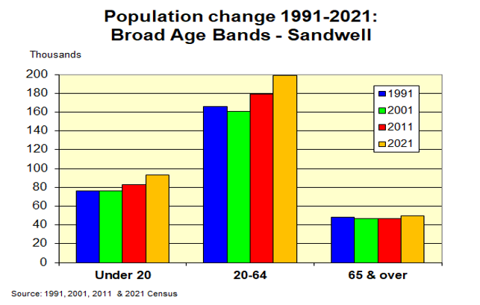
Overall, Sandwell has a young and diverse population. More than 40.0% of residents are under 30, in contrast to approximately 30.0% across England. Additionally, Sandwell remains one of the most ethnically diverse areas in the country, with 42.7% of residents identifying as being from global majority backgrounds, significantly higher than the 18.3% recorded across England and Wales. The largest groups include those of Asian heritage (25%) and Black, Black British, Caribbean or African (3.7%) [4].
The table below indicates the population growth of Sandwell’s six towns between the year 2011 and 2021. Smethwick had the largest population growth of all the towns, growing by 16%. Rowley Regis had the lowest population growth at 7%. The population of all six towns increased in this time period [5].
Town | Change (%)
Smethwick | 16%
Tipton | 13.8%
West Bromwich | 10.95%
Wednesbury | 9.3%
Oldbury | 8.5%
Rowley Regis | 7%

Health
In the 2021 Census, 40.8% of Sandwell residents described their health as "very good", increasing from 37.6% in 2015, however while this percentage has increased, life expectancy for both men and women remains significantly below the national average. On average, men in Sandwell live 76.1years, 3.3 years less than the national average (79.4), and women live on average 80.7 years, 2.4 years below the national average (83.1 years) [6].
According to the Sandwell Pharmaceutical Needs Assessment 2022, 60.2% of respondents reported having a long-term physical or mental health condition lasting more than 12 months [7].
Deprivation
Sandwell’s average deprivation score has improved since 2019, moving up seven places to rank as the 19th most deprived local authority out of 296. However, this improvement reflects Sandwell’s relative position compared to other areas, rather than a direct reduction in deprivation within the borough. In contrast, neighbouring Birmingham remains among the 10 most deprived local authorities by average score, ranked 5th.
The table below shows changes in Sandwell’s rankings across different indicators (where 1 represents the most deprived and 296 the least deprived local authorities nationally):
- Overall average score: Ranked 19th in 2025, improving from 12th in 2019.
- Income: Ranked 9th, unchanged from 2019.
- Education, Skills and Training: Ranked 23rd, down 2 places since 2019.
- Employment: Ranked 12th, down 4 places since 2019.
- Health and Disability: Ranked 34th, up 1 place since 2019.
- Crime: Ranked 39th, down 36 places since 2019.
- Barriers to Housing and Services: Ranked 145th, down 27 places since 2019.
- Living Environment: Ranked 70th, up 53 places since 2019.

Fuel Poverty
There is a significant level of fuel poverty in Sandwell, with many households struggling to afford adequate heating and energy costs. The Fuel Poverty Risk Index names Sandwell as the 6th highest risk area for fuel poverty across 294 local authority areas in England [12]. Reasons for this include existing housing that is poorly insulated, the rising cost of energy and the higher than average number of residents in the lower quartile mean income range.
The Combined Towns Profile of Sandwell produced in 2023, highlights that 20.8% of residents in Sandwell are in fuel poverty. This compares to 13.2% across England [13]. The percentage of residents in each town in fuel poverty can be found in the table below. Smethwick has the highest percentage of residents in fuel poverty (27.7%).
Town | Percentage
Smethwick | 27.7%
Wednesbury | 23.9%
Tipton | 19.8%
Rowley Regis | 19.5%
West Bromwich | 19.1%
Oldbury | 18.1%

Sandwell’s Housing Market
Sandwell’s housing market has changed significantly over the last decade and continues to evolve. In recent years the private rental market has expanded, now accounting for 18.6% of properties in Sandwell, whilst the local authority sector, once the largest sector, continues to decline in number [14]. Property values remain low compared to the wider West Midlands region but remain outside the reach of many households living locally. However, despite a shrinking social housing stock, reducing from 27.5% of all housing in 2011 to 26.6% in 2021, Sandwell had a higher proportion of social rented properties in comparison to other Black Country local authorities, and across England and Wales [15].
The 2021 Census indicates that there were 134,758 dwellings in Sandwell in 2021 [16]. The Census shows that the number of dwellings in the borough grew by 6% between 2011 and 2021 (7,686 dwellings). This growth is lower than that recorded regionally (7.3% across the West Midlands between 2011 and 2021), and nationally (8.5%), over the same time period. This below-average growth in housing contrasts with Sandwell’s above-average population increase during the same period. The borough’s population grew by 11%, more than double the UK average of 6.3%.
House Prices, the Rental Market and Local Housing Allowance in Sandwell
The average house price in Sandwell was £199,000 in December 2024, up 2.7% from December 2023. This was lower than the rise in the West Midlands (4.2%) over the same period. Across the West Midlands and UK, the average house price in December 2024 was £244,000 and £271,000 respectively [17].
For each property type, average prices as of December 2024 in Sandwell were:
- Detached properties: £317,000
- Semi-detached properties: £218,000
- Terraced properties: £184,000
- Flats and maisonettes: £114,000
The average monthly private rent in Sandwell was £845 in January 2025. This was an increase from £822 in January 2024, a 2.8% rise.
Across the West Midlands, the average monthly rent was £912, up from £848 a year earlier, an increase of 7.5%.
Across Great Britain, the average rent price in January 2025 was £1,332, up from £1,226 in January 2024, an increase of 8.6% [18].
This indicates that the average monthly rent is increasing slower on average in Sandwell than it is both regionally and nationally. Despite this, many residents still find themselves unable to afford increasing rents in the private rented sector.
The Local Housing Allowance (LHA), a form of housing benefit that supports those on a lower income, has not increased in line with increasing rents in the private rented sector. As a result, many residents have been forced to make up the shortfall between their rent and the LHA from their limited income, often leaving them unable to afford other essentials. This has resulted in an increase in the number of households in debt, rent arrears, and in some cases, becoming homeless.
​The amount you can receive from the Local Housing Allowance in Sandwell depends on your household size, your age, and whether you rent from a private landlord. As of April 2025, the weekly LHA rates for residents in Sandwell and the Black Country are:​
- Shared accommodation (under 35s): £73.64
- 1-bedroom: £113.92
- 2-bedroom: £143.84
- 3-bedroom: £172.60
- 4-bedroom: £212.88
Properties and Households in Sandwell
Across Sandwell, 53.7% of households owned and occupied their own property. 26.6% of properties are socially rented, and 18.6% privately rented [19]. This can be viewed in the pie chart below.

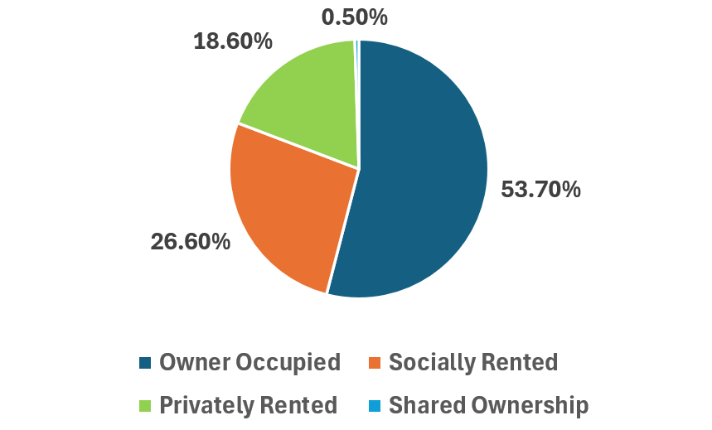
1.8% of all households in Sandwell are without central heating. The percentage of households was highest in Smethwick (2.1%) [20].
8.2% of all households in Sandwell are overcrowded. This was again highest in Smethwick (11.8%). While across England and Wales, the proportion of households with fewer bedrooms than required decreased slightly between 2011 and 2021, there was an increase in Sandwell.
In 2021, 29.2% of Sandwell’s households were without a car or van. This compares with 23.3% across England & Wales [21].
The bar chart below presents the composition of households in Sandwell according to the 2021 Census. The majority of households in Sandwell consist of one person households and married or civil partnership couples [22].

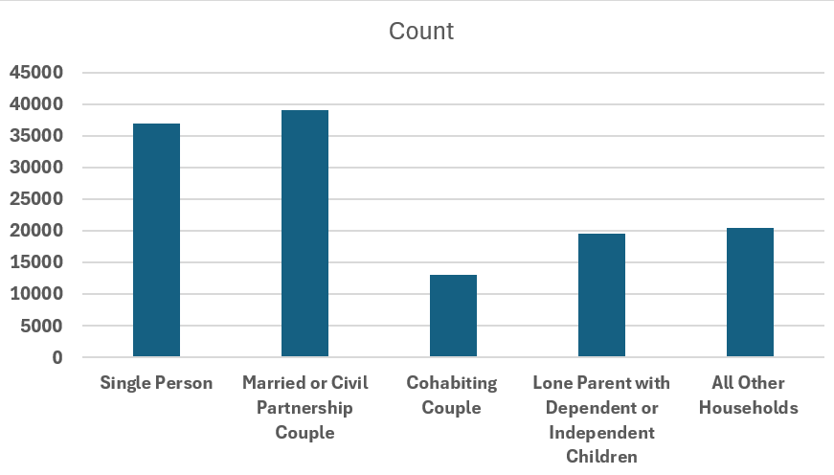
Council Stock Profile
In total, there are 27,781 properties in Sandwell Council’s housing stock. Of these, 26,817 are managed by Sandwell Council, and 964 by PFI Riverside.
Property Type | Number
House | 14,720
Flat | 10,837
Bungalow | 1,576
Maisonette | 648

The slight majority of Sandwell Council’s stock exists as housing. Housing makes up 53% of the total stock. 10,837 flats make up 39% of the housing stock.
Of Sandwell Council’s social housing stock, 11,371 properties have 3 bedrooms (40.9%). 8165 properties have 2 bedrooms (29.4%), 7492 properties have 1 bedroom (27%), and 687 properties have 4 bedrooms (2.5%). This delineation can be viewed in the pie chart below. 22 properties in the social housing stock have 5 bedrooms or more and 44 are stated to contain no bedrooms. These have been grouped together and labelled as ‘other’ in the pie chart due to their low individual totals.
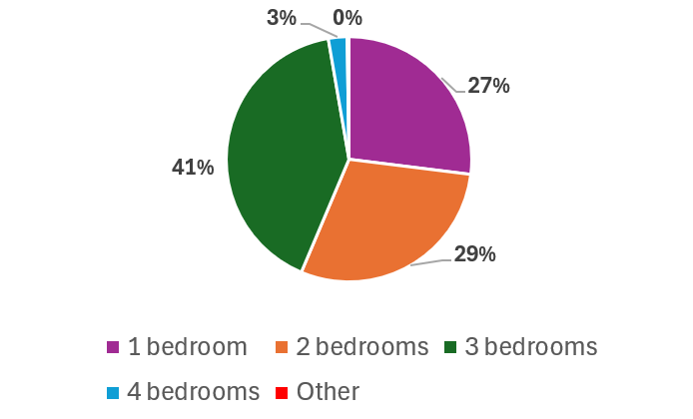

Council Stock by Town
The table below presents the number of social housing properties located in each town. Please note that the 963 properties managed by PFI Riverside are located in West Bromwich.
Town | Number of properties | Town population | Percentage of properties per capita
Wednesbury | 3358 | 41,335 | 8.1%
Smethwick | 3405 | 64,007 | 5.3%
Oldbury | 4072 | 54,929 | 7.4%
Rowley Regis | 4895 | 53,772 | 9.1%
Tipton | 4951 | 44,125 | 11.2%
West Bromwich | 7100 | 83,634 | 8.5%

Wednesbury has the lowest number of social housing properties however Smethwick has the smallest percentage of social housing when measured against the population size of the town.
26% of the council’s social housing stock is within West Bromwich, the highest percentage of any town. However, for the relative population size, Tipton has the highest overall percentage of social housing properties.
The following table presents the percentage of properties that are owner occupied, socially rented and privately rented in Sandwell’s six towns [23].
Area | Owner occupied | Socially rented | Privately rented | Shared ownership
Wednesbury | 53.3% | 31.1% | 14.6% | 0.4%
Smethwick | 47.3% | 22.9% | 28.4% | 0.5%
Oldbury | 58.8% | 21.7% | 18.5% | 0.5%
Rowley Regis | 58.3% | 25.7% | 14.9% | 0.5%
Tipton | 47.4% | 35.6% | 15.9% | 0.5%
West Bromwich | 55.2% | 25.9% | 18% | 0.4%
Sandwell | 53.7% | 26.6% | 18.6% | 0.5%

Tipton again has the largest percentage of social housing (35.6%). Oldbury has the smallest percentage of social housing (21.7%).
Oldbury has the highest percentage of homeowners (58.8%), whereas Smethwick has the highest percentage of privately rented accommodation (28.4%), by a large margin of 9.9%.
Housing Associations
Housing associations operating in Sandwell also own and manage social housing properties in addition to those in Sandwell Council’s social housing stock. Please note that the 964 properties managed by the housing association PFI Riverside, are included in the stated 27,781 properties within Sandwell Council’s housing stock.
Sandwell Council advertise the social housing properties of housing associations to housing register applicants. Applicants on the housing register will be directed to the housing association.
The housing associations, operating in Sandwell, are listed below, in addition to the number of social housing properties that they own in parenthesis, if this information is known to the council.
- Black Country Housing Group
- Bromford
- Citizen Housing
- Clarion (40 properties, including 21 two bedroom flats, 1 maisonette and 18 houses)
- Green Square Accord (369 properties)
- Lyng Community Association
- Midland Heart (1190 properties, 70 of which are supported housing)
- Nehemiah (6 properties)
- Optivo
- Platform Housing Group (122 properties, including 28 shared ownership)
- Riverside
- Sanctuary (601 properties)
- Stonewater (921 properties, including 409 houses, 457 flats, of which 31 are retirement living properties, 34 bungalows and 21 bedsits)
- Trident (60 properties)
- Pinnacle Housing
- PFI Riverside (964 properties, included in Sandwell Council’s housing stock)

The Impact of Right to Buy
The table below presents the total number of properties that have been purchased from the council, under the Right to Buy housing scheme, in the last 5 years. In total, there were 4,828 applications by tenants to purchase their council property in this period. 1,828 of these applications (37.8%) came in the year 24/25, an exponential increase on the previous figures for the years 2019 to 2024. However, just 174 of these applications were granted (9.5%). The observed increase in applications was likely caused by a number of tenants seeking to purchase their council property before legislation regarding the right to buy scheme changed, and the available discount for tenants subsequently reduced.
In total during this period (2019-2025), the council lost 1,369 properties in its social housing stock through the Right to Buy scheme. That number equates to 4.9% of the current and total social housing stock. In the same time period, the council built and thus added 339 properties to its social housing stock. The number of newly built properties (339), in addition to the number of properties re-purchased by the council (254), have replaced 43% of the properties lost from the social housing stock through Right to Buy.
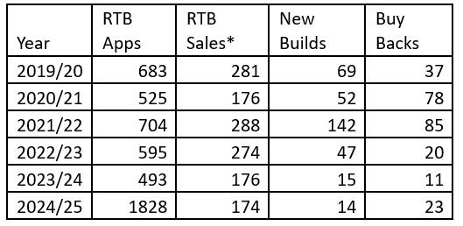
Due to changing government legislation and a reduction in the discount offered through the Right to Buy scheme, the number of Right to Buy applications received by Sandwell Council is likely to decrease in the near future. The changes to the discount came into force on the 21st of November 2024, and saw a reduction in the discount, from a maximum discount of £102,400 to £26,000.

Sandwell’s Future Social Housing Stock
Future Housing Stock
The Sandwell Housing Market Assessment of 2024 projects that by 2041, 39,726 social housing and affordable housing units for renting will be required [24]. According to the data, there are currently 35,117 rented social housing and affordable housing units in the borough. Projections indicate that 4,609 additional affordable and social housing units will be needed by the year 2041.
The table below shows the projections for the size of accommodation required in the affordable rented/social rented sector in Sandwell in 2041 [25]. The table shows that of the 4,609 additional units required, 34.5% should be four bedroom properties with a further 25.6% as one bedroom accommodation. The projections indicate that 20.3% should have three bedrooms and 19.6% should have two bedrooms. The future projections do not account for future socially rented properties lost through the Right to Buy scheme.
Size of home | 2024 | 2041 (required) | Change required | % of change required
One bedroom | 10,492 | 11,670 | 1,178 | 25.6%
Two bedroom | 11,136 | 12,041 | 905 | 19.6%
Three bedroom | 11,960 | 12,894 | 934 | 20.3%
Four or more bedrooms | 1,530 | 3,121 | 1,591 | 34.5%
Total | 35,117 | 39,726 | 4,609 | 100%

The projections indicate that a higher proportion of new socially rented and affordable rented accommodation should consist of four or more bedrooms.
Future Housing Developments in Sandwell
The Sandwell Council Housing Strategy outlines ambitious plans for future housing developments in the borough. The strategy sets a target of building 100-150 new council homes each year through 2028 [26].
Major regeneration projects in Sandwell include the Friar Park and Swan Lane housing build programmes. The Friar Park scheme plans for 630 new homes to be built by 2030, including 158 affordable properties. The Swan Lane project plans for the building of 147 new affordable homes.
Development plans also include a target for 400 new affordable homes to be delivered by registered providers before 2028, the delivery of 122 new affordable keyworker homes by Catalyst Mutual Enterprise, and the use of the Housing Revenue Account to acquire land for new developments [27].
The below table presents the total number of properties that have been delivered and subsequently added to the housing stock over the last five years.
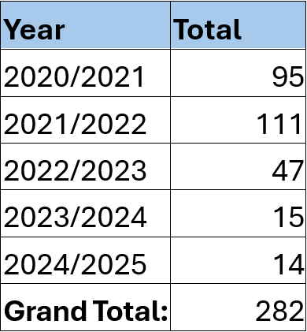

Published in 2023, Sandwell Council’s housing strategy commits the council to exploring specialist housing options for older people and larger family homes. The Housing Strategy outlines that the council will seek to support community-led housing, and community land trusts to prevent Right to Buy losses and investigate small council-owned sites for community-led developers.
In delivering specialist housing options for older people, the council have opened a new, specialist built, extra care housing scheme at Willow Gardens, that offers a mixture of one and two-bedroom apartments, with 24hr support onsite and care services available that are tailored to the individual’s needs. There are 90 self-contained apartments at Willow Gardens, consisting of 23 two bedroom units and 67 one bedroom units, including 5 which are fully wheelchair compliant. Work has also been completed at Walker Grange to refurbish a smaller number of units to support older people with dementia. The council’s new build scheme, in addition to single property acquisitions, is helping to deliver additional 4-bed capacity for use as larger family homes.
In March 2024, Sandwell Council passed a motion to include co-operative housing models in the Local Plan. The Local Plan, as of April 2025, is awaiting publication, following examination by the Secretary of State. There are currently over 900 housing co-operatives in the UK involving over 196,500 homes. Co-operative housing models are regarded to produce higher-quality housing at lower rents than most private rented models, while fostering a strong sense of community.
Sandwell Council has 137 property assets on its land register which have been declared surplus to requirement. The 137 asset sites include:
• Small areas of land which are managed as part of the commercial estate.
• Small areas of land, some of which are garage sites and forecourts adjacent to housing developments.
• Open space which is deemed to be of low quality.
• Potential development sites that may be suitable for housing developments, employment or regeneration.
Of these asset sites, 36 were identified by Sandwell Council as having potential significant development potential. Subsequently, and to date, 4 sites have been disposed of for future development. These sites include land at Woden Road West and Black Country New Road, Mounts Road Play Area, land at Old Park Lane, and the Old Park Lane Cluster.
In January 2025, Sandwell Council also responded in favour to a government consultation on changes to the Right to Buy scheme, advocating for a reduction in the discount available to buyers, and for stricter rules on the resale of properties, to prevent the immediate re-letting of purchased council homes. It is hoped that changes to the Right to Buy scheme will help to preserve the current social housing stock.

Housing Needs for Sandwell’s General Population
Housing Register Overview
In July 2020 Sandwell Council introduced a new Housing Allocations Policy that adjusted the residency test required to join the housing register. The new Housing Allocations Policy reduced the amount of time that an applicant must have lived in Sandwell, in order to qualify for the housing register, from 5 years to 2 years. This is likely to have contributed to the growth of the housing register from around 7,600 households in May 2020 to 10,591 in August 2022 (the publication date of the previous Housing Needs Assessment).
Since publication of the previous Housing Needs Assessment, the number of households on the register has significantly increased, almost doubling from 10,591 in August 2022 to 20,423 in March 2025.
Of these 20,423:
- 16 are decant applications
- 276 households on the register require an adapted property.
- 330 households currently on the housing register are stated as homeless.
- 5,476 households on the housing register are current Sandwell Council tenants.
The bar chart below illustrates the proportion of each age group that are currently on the housing register, using the age bracket of the head of household.
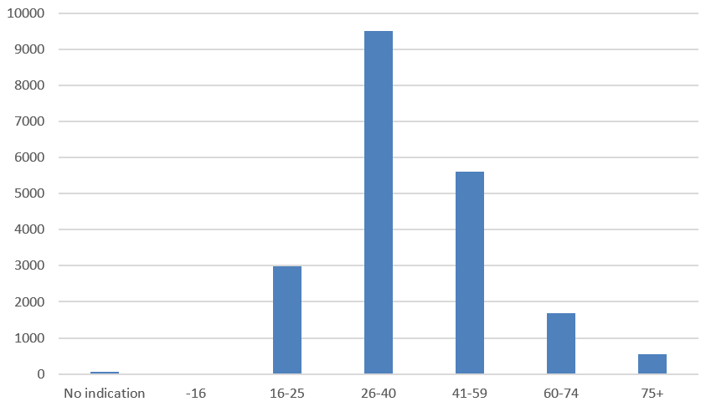
9,506 of 20,423 households have a head of household between the ages 26-40. This compromises 47% of the total housing register. There are currently 2 head of households on the housing register under the age of 16. There are 2,998 head of households between the ages 16-25 (14%), 5,611 head of households aged 41-59 (27%), 1,691 head of households aged 60-74 (8%), and 549 head of households aged 75+ (2.6%). 66 have given no indication as to the age of the head of the household on the application.
The vast majority of households on the housing register are currently in band 5. 15,389 households are in band 5, accounting for 75% of the housing register. 25% of households in the housing register are in bands 1-4 (a priority band). Of those, the majority are in band 3 (2817,14%). Those not accounted for in the table below are decant applications.
Priority Band | Count
Band 1 | 582
Band 2 | 1512
Band 3 | 2817
Band 4 | 107
Band 5 | 15389

Single person households are the largest household type on the housing register (8,267 households). They account for 40% of the housing register. The numbers of single person households on the housing register have significantly grown in size since the previous Housing Needs Assessment in 2022, which states a total of 2,753 single person households. This increase is likely due to the changing in criteria for acceptance onto the housing register as outlined in the previous Housing Allocations Policy in 2020.
There are 5,290 single parent with children households on the housing register and 4,085 married couples with children households on the housing register. These household types make up 26% and 20% of the housing register respectively. There are 2,483 cohabiting couples or all adult households on the housing register (12%). The remaining 320 households have not stated their household make up. This information can be viewed in the pie chart below.

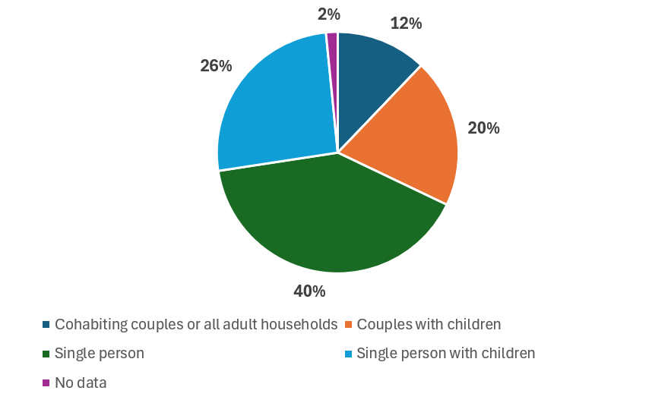
The majority of households on the housing register require a one bedroom property (10,687). This accounts for 52% of the housing register. 5289 households, the second largest group (26%) of the housing register, require a two bedroom property. 1452 households require a property with four bedrooms or more. This accounts for 7% of the housing register. The table below presents the number of bedrooms needed for households currently on the housing register. Data for 72 households is not available.
Number of Bedrooms Needed | Number of households
0 | 58
1 | 10,687
2 | 5,289
3 | 2,865
4 | 1111
5 | 260
6 | 67
7 | 12
8 | 0
9 | 1
10 | 1

Bidding activity
The council currently operates a choice-based lettings system for the allocation of its vacant properties whereby applicants are invited to express an interest in renting a vacant property, often referred to as ‘bidding’. The bidding process provides an indication of property type demand, i.e. a low number of bids implies low demand. Where increased average wait times from 1st bid to let can be observed, this typically reflects heightened demand or low supply.
The table below presents the average number of weeks, from a households first bid on a property, to a property being let to the household, categorised by the households priority band.
Housing Register Priority Band | Average Number of Weeks (1st bid to let)
Band 1 | 41 weeks
Band 2 | 75 weeks
Band 3 | 156 weeks
Band 4 | 109 weeks
Band 5 | 83 weeks

While a higher band indicates a higher priority on the waiting list, the average number of weeks from the 1st bid to let, is significantly higher in band 3 than it is in bands 4 and 5. This is likely due to households in band 3 requiring specific property types that are currently in high demand. For example, if a household is awarded a higher band priority as they are overcrowding, the household will only be seeking to bid on properties with the appropriate number of bedrooms. As 3 and 4 bedroom properties are in higher demand, than the number of properties available, waiting times are increased. The increased waiting times for 3 or 4 bedroom properties in bands 1, 2, 3 and 5 is displayed in the table below. Statistics for band 4 have been omitted due to the low number of households in band 4.
Bedroom number | Average Number of Weeks (1st bid to let) for households in band 1
1 | 29 weeks
2 | 38 weeks
4 | 56 weeks
4 | 174 weeks

Bedroom number | Average Number of Weeks (1st bid to let) for households in band 2
1 | 39 weeks
2 | 68 weeks
3 | 140 weeks
4 | 149 weeks

Bedroom number | Average Number of Weeks (1st bid to let) for households in band 3
1 | 51 weeks
2 | 179 weeks
3 | 216 weeks
4 | 468 weeks

Bedroom number | Average Number of Weeks (1st bid to let) for households in band 5
1 | 56 weeks
2 | 96 weeks
3 | 293 weeks
4 | 270 weeks

As can be viewed in the tables above, the average number of weeks before a property is let, is higher for 3 and 4 bedroom properties. The waiting time for households in band 3 for a 4 bedroom property is significantly high (468 weeks). Given that households in band 5 are more likely to be single person households, and thus require a 1 bedroom property, this is likely to have led to the lower waiting times observed in band 5 than band 3, as referenced above.
Waiting times for a house are also considerably higher than that for flats, bungalows and maisonettes. Average waiting times by property type, for all households on the register, are presented in the table below.
Property Type | Average Number of Weeks (1st bid to let) for households in all bands
House | 179 weeks
Flat | 59 weeks
Bungalow | 52 weeks
Maisonette | 35 weeks

The table clearly presents a higher demand for houses than flats. Despite the housing stock consisting of 14,720 housing units and only 10,837 flats, waiting times for a house are around 3x than that for a flat, highlighting the increased levels of demand.

Housing Needs for Specific Groups in Sandwell
Disabled Households
A disability can be defined as a physical or mental impairment that has a substantial and long-term adverse effect on an individual’s ability to carry out normal day-to-day activities. This includes, but is not limited to, people with ambulatory difficulties, blindness, learning difficulties, autism and mental health needs.
The 2021 Census shows that in 2021, 20% of the resident population in Sandwell are disabled under the Equality Act, compared to 18.1% in the West Midlands and 17.3% nationally [28]. Further analysis shows that 48.5% of all residents disabled under the Equality Act in Sandwell had a condition that often limits day-to-day activities.
The percentage of residents who are disabled is highest in Wednesbury (20.2%) and lowest in Smethwick (14.7%) [29].
The table below presents the current number, as of August 2024, of individuals in Sandwell with a severe health condition, in addition to the projected numbers in the year 2041 [30].

Health condition | 2024 | 2041 | Total change | Percentage change (%)
People aged 65 or over disabled under the equality act | 21,527 | 30,631 | 9,104 | 42.3% increase
People aged 18-64 with impaired mobility | 11,229 | 12,805 | 1,575 | 14% increase
People aged 18-64 with a common mental health problem | 40,293 | 46,078 | 5,785 | 14.4% increase
People aged 65 and over with dementia | 3,492 | 5,316 | 1,824 | 52.2% increase
People all ages with a learning disability | 6,505 | 7,867 | 1,363 | 21% increase

The table shows that the number of those aged 65 or over disabled under the Equality Act, is expected to increase by 42.3% between 2024 and 2041 in Sandwell. The table also indicates an increase of 14.0% in the number of people aged 18-64 in the borough with impaired mobility, a rise of 14.4% in the number of people aged 18-64 in Sandwell with a common mental health disorder, an increase of 52.2% in the number of people aged 65 or over with dementia, and an increase of 21% in the number of people in Sandwell with a moderate or severe learning disability.
The second table, as outlined below, presents the number of people in Sandwell that currently, and are projected to, in the year 2041, require assistance with activities [31].
People requiring assistance with activities | 2024 | 2041 | Total change | Percentage change (%)
People aged 65 and over that are unable to manage at least one mobility activity on their own | 9,308 | 13,380 | 4,072 | 43.8%
People aged 65 and over who need help with at least one domestic task | 11,635 | 20,943 | 9,308 | 80%
People aged 65 and over who need help with at least one self-care activity | 14,570 | 20,727 | 6,157 | 41.3%
People aged 18-64 with a serious personal care disability | 1,785 | 2,054 | 269 | 15.1%

The table shows that the number of those aged 65 or over that are unable to manage at least one mobility activity on their own, is expected to increase by 43.8% between 2024 and 2041. The table projects an increase of 80.0% in the number of people aged 65 and over who need help with at least one domestic task, an increase of 42.3% in the number of people aged 65 and over who need help with at least one self-care activity and an increase of 15.1% in the number of people aged 18-64 with a serious personal care disability. These changes better reflect the projected change in the demographics of the population (an ageing population) rather than a notable change in the overall health of people in Sandwell.

Older People
The 2021 Census data, shows that 14.5% of Sandwell’s population were aged 65 or over [32]. This compares to a figure of 18.8% across the West Midlands region and 18.4% nationally, indicating that the population of Sandwell is currently younger than average. According to the 2021 Census, 17.8% of households in Sandwell were older person only households (households where all members are 66 and over), compared to 22.6% regionally and 22.0% nationally [33].
Older person groups record a higher level of owner-occupation with no mortgage than other households in Sandwell, and single older person households are more likely to live in the social rented sector. Older person households were also more likely than average to have multiple spare bedrooms in their home [34].
The population percentage of 65s or over, is projected to increase notably in Sandwell by 2041, from 51,258 in 2024, to 72,608 in 2041, a rise of 41.7%. The projections also suggest that there will be an increase in the number of households headed by someone aged over 65 in Sandwell from 28,978 in 2024, to 46,203 in 2041, an increase of 59.4%. The projections indicate that the proportion of older persons living alone in Sandwell will increase from 54.4% in 2024, to 56.3% in 2041 [35].
The table below illustrates the projected number, size and form of housing that will be required for ‘older person households’ in the year 2041 in Sandwell [36].
Size of home | Owner occupied | Private rented | First homes | Shared ownership | Social/ affordable rented
1 bedroom | 2,038 | 660 | 2 | 68 | 6,759
2 bedroom | 10,397 | 1,579 | 1 | 24 | 4,759
3 bedroom | 16,522 | 874 | 0 | 5 | 898
4 bedroom | 1,354 | 107 | 0 | 0 | 154
Total | 30,311 | 3,221 | 3 | 97 | 12,570

The table reflects the projected future housing demand within Sandwell for ‘older person households’. The projections indicate a notable amount under-occupying within the owner-occupied tenure, reflecting that some older persons households choose to remain in their home rather than downsize to a smaller property.
General/ Adapted Living
With an ageing population, an increased amount of accessible and adapted homes will be required in the borough. Between 2005 and 2023 Sandwell Council awarded 4,595 grants to council tenants to complete major adaptations. The bar chart below indicates the requirement for accessible and adaptable homes in Sandwell in 2041. The bar chart outlines the amount of general housing that will be needed for under and over 65s, and the total amount of supported housing that is needed. Of those sums, the bar chart also delineates the amount that will need to be affordable housing [37].
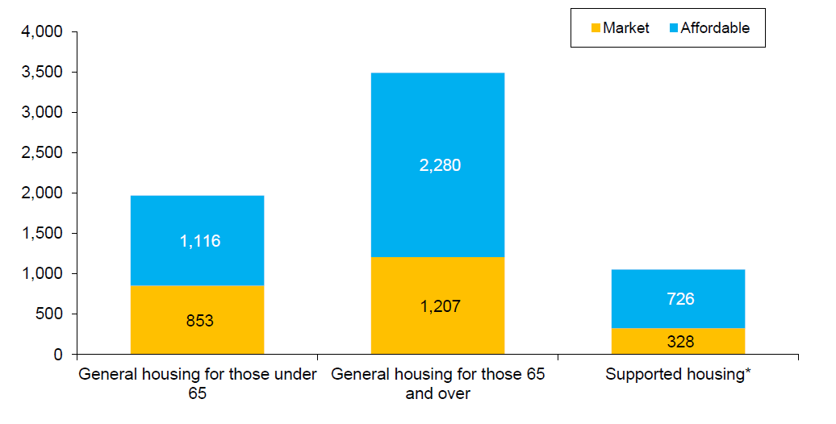
In total 6,510 accessible and adaptable homes are required in 2041 in Sandwell, of which 2,388 should be in the market sector and 4,122 in affordable accommodation. Of the 6,510 accessible and adaptable homes required, 5,456 should be in the general housing stock and 1,053 in supported accommodation. For 6,510 accessible and adapted homes, around 4.3% of the total stock in 2041 would need to meet this criteria.
The second bar chart below presents the projected required number of wheelchair user dwellings in 2041 [38].
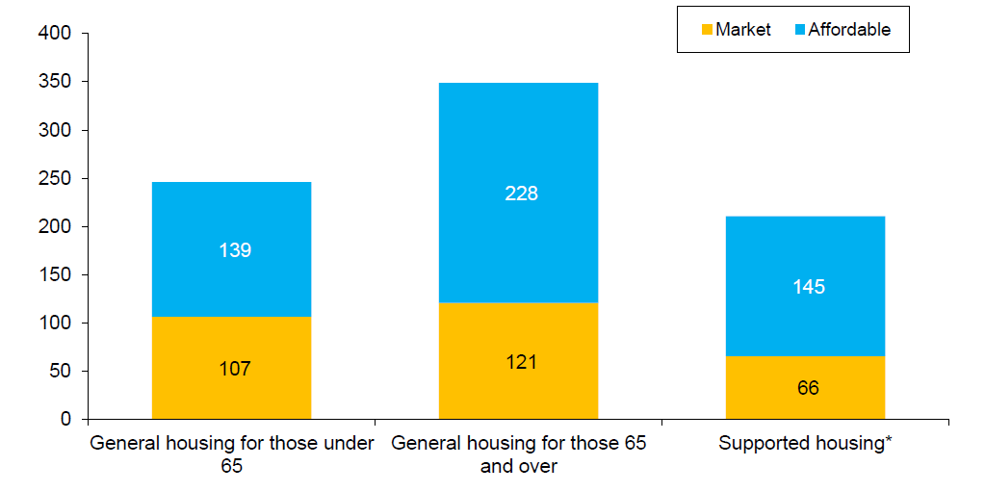
In total, according to projections, 806 wheelchair user friendly dwellings will be required in Sandwell in 2041, of which, 513 will need to be affordable accommodation. Of the 806 wheelchair user dwellings required, 595 should be in the general housing stock and 211 in supported accommodation. Overall, the requirement for 806 wheelchair user dwellings will mean that in 2041, around 0.5% of the total stock should be available to meet this criteria.
In addition to specialist accommodation, the council provides support and assistance to help people remain in their current home. Adaptions made to dwellings could reduce the requirement for new homes meeting the M4(2) standard. 916 applications were received, under the Disabled Facilities Grants programme between 2018 to 2023. Of this sum, 869 Disabled Facilities Grants were awarded, and work was completed, to make adaptations to accommodation.
Supported living for adults with learning difficulties and autism
The below table, featured in the 2022 Housing Needs Assessment, presented data for the number of supported living housing placements needed through to the year 2026. Projections were made by the Commissioning Support Planning Team for the years 2023 to 2026. Commissioners still project that around 50 placements will be needed in the years 2026, 2027 and 2028, showing a stabilisation in the number of placements required, following the great increase observed between the years 2021 and 2023.
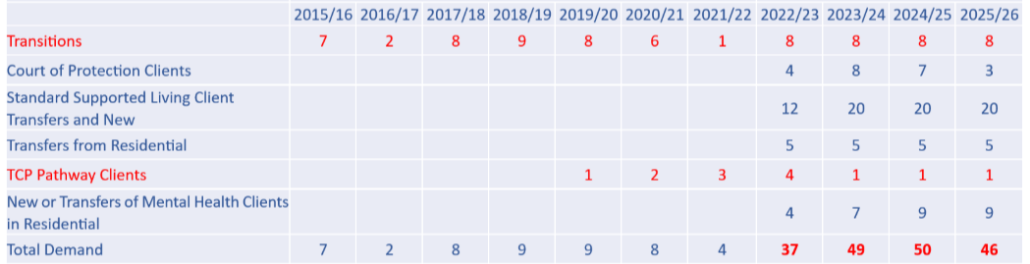
Accommodation needs for young people
Sandwell Council aim to provide accommodation for young people that is high quality and affordable to prevent homelessness.
Sandwell Council and St Basil’s have formed a strategic partnership to provide young people with affordable housing and employment opportunities, to ensure a successful transition to independent living.
St Basils operate four multi-property sites in Sandwell at All Saints House, Boothroyd House, Hallam House, and Apprentice House.
Young people who are under the age of 26, and are employed, in an apprenticeship, or awaiting an offer, can apply for accommodation at St Basils. Weekly rent at All Saints House, Boothroyd House and Hallam House is £75. Weekly rent at Apprentice House is £50.
Across the four sites, there are 86 properties managed by St Basil’s for use as accommodation for young people. These 86 properties include 32 properties with a shared kitchen and bathroom, and 54 self-contained flats, including 27 studio flats and 27 1 bedroom flats.

Care Experienced Young People
In December 2024, the Sandwell Council Cabinet agreed and approved a report to recognise care experience as a protected characteristic.
By recognising care experience as a protected characteristic, Sandwell Council must provide access to stable and suitable housing by prioritising the needs of care experienced young people in policy decisions. The council must ensure that housing policies explicitly consider the needs of care experienced young people, and that housing outcomes for care experienced young people are routinely monitored. Future housing support initiatives must also prioritise the needs of care experienced young people.
To help enable our care experienced young people to successfully transition to adulthood, it is Sandwell Council’s responsibility as a corporate parent, to ensure that our care experienced young people are given a safe and supported pathway for independent living. Sandwell Council therefore provide care experienced young people with:
- Independent living taster flats. Sandwell Council have 25 training flats, that can be lived in for up to 12 months. Living support is provided in these flats.
- A ‘crash pad’ used for sessions to build on independence skills.
- A setting up allowance of £2000.
- Priority for social housing in Band 1, up to the age of 25. Care Experienced young people can join the housing register at 16.
To better support and equip our care experienced young people, Sandwell Council could also act as a guarantor or provide a deposit for a privately rented property.
Housing needs for Ethnicity Groups
The table below delineates the number of social housing applications by ethnicity.
All Live Social Housing Applications by Ethnicity | Total
Asian or Asian British Bangladeshi | 704
Asian or Asian British Indian | 1,044
Asian or Asian British Other | 160
Asian or Asian British Pakistani | 204
Black or Black British African | 1,476
Black or Black British Caribbean | 1,504
Black or Black British Other | 29
Chinese or Other Ethnic Group Chinese | 15
Chinese or Other Ethnic Group Other | 3
Gypsy | 31
Mixed Other | 66
Mixed White and Asian | 455
Mixed White and Black African | 109
Mixed White and Black Caribbean | 763
White British | 9,354
White Irish | 76
White Other | 388
Total | 20,423 (including 4,042 households for which we are without data).

*Data on 4,042 households was not available.
9,354 households currently on the housing register were White British households. This accounts for 45.8% of the housing register. The second largest group were Black or Black British Caribbean, accounting for 7.4% of households on the housing register. The third largest group, Black or Black British African, accounts for 7.2% of households on the housing register.
Certain households of global majority groups including Asian or Asian British Other and Asian or Asian British Pakistani, were more likely to live in an overcrowded household.
The table below presents, by ethnicity, the percentage of households, on the housing register, that are known to be overcrowded. Please note that the percentage of households listed in the table below only represents households that are known to be overcrowded. The actual percentages could and are likely to be higher.
Group | % of households that are known to be overcrowded
Asian or Asian British Bangladeshi | 8.4%
Asian or Asian British Indian | 5.2%
Asian or Asian British Other | 22.5%
Asian or Asian British Pakistani | 18.7%
Black or Black British African | 7.2%
Black or Black British Caribbean | 4.2%
Black or Black British Other | 9%
Chinese or Other Ethnic Group Chinese | 20%*
Chinese or Other Ethnic Group Other | 0%**
Gypsy | 0%***
Mixed Other | 9%
Mixed White and Asian | 2.4%
Mixed White and Black African | 9.9%
Mixed White and Black Caribbean | 4.1%
White British | 6.2%
White Irish | 6.5%
White Other | 9.3%
Average | 8.8%****

*A small sample size was used to calculate this percentage.
**A small sample size was used to calculate this percentage.
***There was insufficient data to calculate a percentage
****The average is calculated using the mean of all groups, not accounting for the number of households pertaining to each group. The average does not include the percentage for the groups Chinese or Other Ethnic Group Chinese, Chinese or Other Ethnic Group Other and Gypsy households.
Migrants, Asylum Seekers and Refugees
When analysing patterns and data on migration, the country of birth of a migrant, refugee or asylum seeker is the most commonly used measurement and has been used in the UK Census since 1851.
A refugee is someone who has a well-founded fear of being persecuted for reasons of race, religion, nationality or membership of a particular social group. An asylum seeker is someone who has left their country of origin and formally applied for asylum, but their application has not yet been decided or granted.
A migrant is someone who has moved from one country to another, not for reasons of asylum or refuge. Often the move is for work, education or to be with family [39].
The chart below includes information from the 2011 and 2021 Census to show the change in number of migrants in Sandwell by their country of birth from 2011 to 2021 [40].

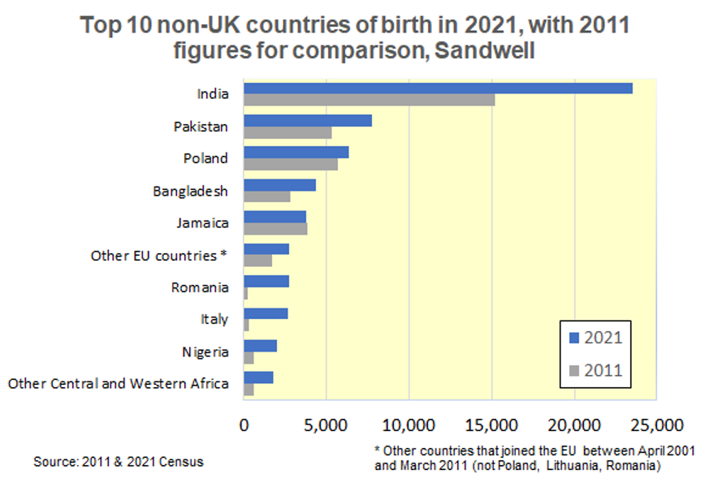
According to the 2021 Census, almost one in four (23.6%) residents of Sandwell were born outside the UK, compared with one in six nationally. This proportion puts Sandwell in the top 50 Local Authorities across England & Wales [41]. India remained the most common country of birth outside the UK in 2021 (23,530 people, 6.9% of all residents). Relatively large proportions of Sandwell residents were born in Pakistan (2.3%) and Bangladesh (1.3%). The number of people who were born in Poland grew by 12.5% since the previous census, from 5,670 in 2011 to 6,380 in 2021. The number born in Romania rose by almost 1200%, from 210 in 2011 to 2,710 in 2021. 47,670 Sandwell residents (13.9%) held a non-UK passport; one of the most common non-UK passport held was Polish (6,860, 2.0% of all residents). 2,620 usual residents (0.8% of the population) had an address outside the UK one year before the Census, up 11.4% from 2,350 (0.8%) in 2011.
Data provided by the Sandwell Council Public Health Team also highlights hotspots for areas of increased migration in the borough. The map below presents the areas of Sandwell where migrants, who have applied for national insurance registration, live.

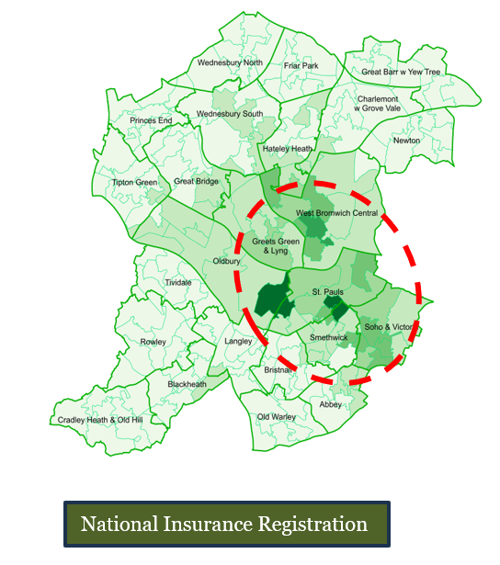
Migration numbers tends to increase around the town of Smethwick (particularly St Pauls and Soho and Victoria wards), as well as the towns of West Bromwich and Oldbury.
High numbers of asylum seekers can also be viewed in similar locations, most commonly in the areas of St. Pauls, Smethwick and Soho and Victoria. However, there are several wards within Sandwell where no asylum seekers are placed, including Great Barr, Newton, Princes End, Hateley Heath, Charlemont with Grove Vale and Blackheath. This suggests that there has been a disproportionate dispersal in the re-settlement of migrants in wards and towns in Sandwell. The map below highlights areas of the borough that contain an increased number of asylum seekers [42].
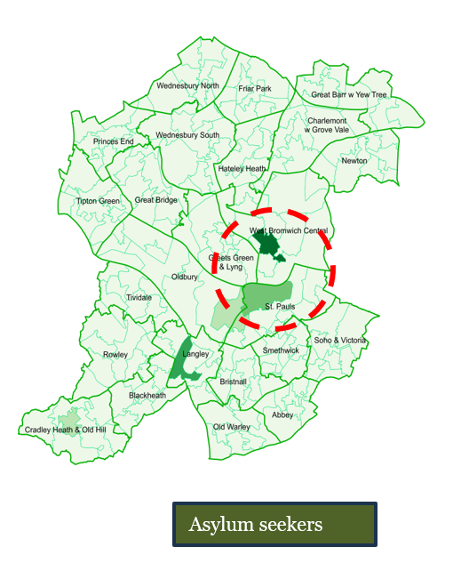

The largest number of asylum seekers in Sandwell were born in Iran. There are 178 asylum seekers in Sandwell from Iran. The second largest groups of asylum seekers in Sandwell are from Iraq (111), and Afghanistan (101). This data can be viewed in the chart below, which details the number of asylum seekers in the borough, prior to February 2024 [43].

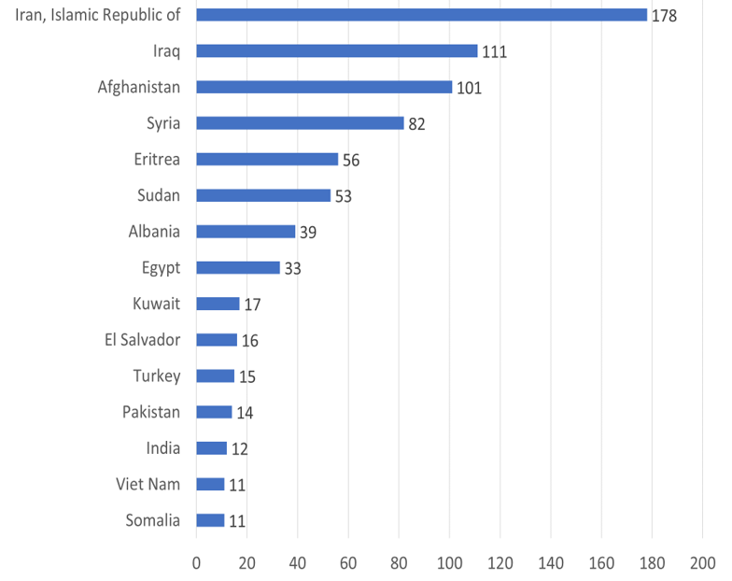
Gypsy, Roma, and Traveller communities residing in permanent dwellings
There is a long history of Gypsies and Travellers residing in the Black Country.
The collective term Gypsey refers to English Gypsies, Scottish Gypsies or Travellers, Welsh Gypsies and other Romany people. The term Irish Traveller refers to travellers with specific Irish roots and the term Roma refers to migrants from Central and Eastern Europe. The 2021 Census presents data separately for the Gypsy or Irish Traveller group and Roma people [44].
According to the 2021 Census, in Sandwell there were 324 Gypsies or Irish Travellers (0.09% of the population) and 375 Roma people (0.11% of the population). There were 31 Gypsy households on the housing register as of March 2025.
‘White Gypsy or Irish Traveller’ was the smallest ethic group in the West Midlands in the 2021 census, with a population of 6,207. The next smallest ethnic group was ‘White Roma’ with a population of 6,809.
Data from the Black Country Gypsy and Traveller Accommodation Assessment, indicates that Sandwell has the lowest proportion of the total number of Gypsies, Irish Travellers and Roma people in the Black Country of all 4 local authority areas (just 5%) [45]. This may be reflective of the lack of pitching sites available within the borough. There is currently only one permanent traveller site in Sandwell, with 16 pitches at Hillside View, Brierley Lane, and Bilston. The number of pitching sites (16) in Sandwell, is lower than that in the other Black Country local authority areas. The table below presents the number of authorised pitches available in each Black Country local authority area [46].
Local Authority Area | Sites | Pitches
Dudley | 4 | 38
Sandwell | 1 | 16
Walsall | 7 | 36
Wolverhampton | 2 | 42
Total | 14 | 132

The 2021 Census shows that across England and Wales, there were 71,440 people who identified as a Gypsy or Irish Traveller.
The chart below illustrates the percentage of the 71,440 Gypsies and Irish Travellers living in each type of dwelling [47].
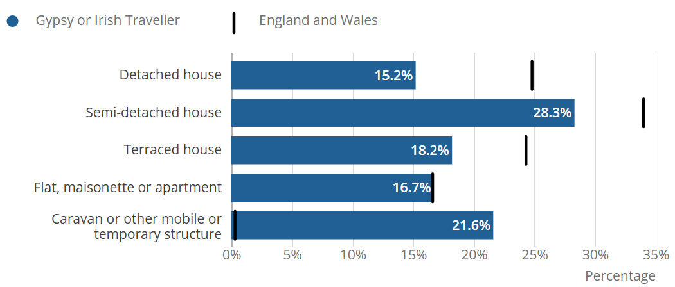
In total, 78.4% of Gypsy and Irish travellers nationally lived in a permanent dwellings.
Nationally, semi-detached houses were the most common accommodation type for people who identified as a Gypsy or Irish Traveller (28.3%).
In comparison with the population of England and Wales, people who identified as Gypsy or Irish Traveller were:
- over twice as likely to live in social rented accommodation (42.3% compared with 16.6%).
- four times less likely to own their accommodation with a mortgage, loan or shared ownership (9.5% compared with 35.6%) [48].
People who identified as Gypsy or Irish Traveller were over three times more likely to live in overcrowded accommodation than the national population (26.5% compared with 8.4%).
Those who identified as Roma were also more likely to live in overcrowded accommodation, over a quarter (26.5%), lived in overcrowded accommodation [49].
The 2022 Black Country Gypsy and Traveller Accommodation Assessment highlights problems associated with living in permanent dwellings, as identified by the Gypsy and Traveller population in Sandwell. These problems include social isolation, a lack of freedom and being misunderstood by the community [50].
Findings of the 2022 Black Country Gypsy and Traveller Accommodation Assessment suggest that there may be households who currently reside in permanent dwellings, that would prefer to reside on a site.

References
[1] Office for National Statistics, ‘How the population changed in Sandwell: Census 2021’ (June 2022) https://www.ons.gov.uk/visualisations/censuspopulationchange/E08000028/ [Accessed March 2025]
[2] Office for National Statistics, ‘How the population changed in Sandwell: Census 2021’ (June 2022) https://www.ons.gov.uk/visualisations/censuspopulationchange/E08000028/ [Accessed March 2025]
[3] Office for National Statistics, ‘How the population changed in Sandwell: Census 2021’ (June 2022) https://www.ons.gov.uk/visualisations/censuspopulationchange/E08000028/ [Accessed March 2025]
[4] Sandwell Trends, ‘Ethnic Group and Language’ https://www.sandwelltrends.info/ethnicity-religion-country-of-birth/ [Accessed March 2025]
[5] Sandwell Trends, ‘Population Change since 2011’ https://www.sandwelltrends.info/population/population-by-ward/ [Accessed March 2025]
[6] Sandwell Council, ‘Sandwell Authority Monitoring Report 2023-2024’ P.5
[7] Public Health Sandwell Council, ‘Sandwell Pharmaceutical Needs Assessment 2022’ P.87
[8] Sandwell Trends, ‘Sandwell and the English Indices of Deprivation 2025’ https://www.sandwelltrends.info/deprivation-2025/ [Accessed November 2025]
[9] Nomis Official Labour Market Statistics, ‘Labour Market Profile Sandwell’ https://www.nomisweb.co.uk/reports/lmp/la/1946157189/printable.aspx [Accessed March 2025]
[10] HDH Planning and Development Ltd, ‘Sandwell Council Market Assessment Update 2024’ P.20
[11] Research Sandwell, ‘The Combined Towns Profile of Sandwell 2023’ P.4
[12] Open Data Institute, ‘Fuel Poverty Risk Index 2023’ https://theodi.org/insights/reports/fuel-poverty-risk-index-2023/ [Accessed March 2025]
[13] Research Sandwell, ‘The Combined Towns Profile of Sandwell 2023’ P.9
[14] HDH Planning and Development Ltd, ‘Sandwell Council Market Assessment Update 2024’
[15] HDH Planning and Development Ltd, ‘Sandwell Council Market Assessment Update 2024’
[16] HDH Planning and Development Ltd, ‘Sandwell Council Market Assessment Update 2024’ P.21
[17] Office for National Statistics, ‘Housing Prices in Sandwell’ https://www.ons.gov.uk/visualisations/housingpriceslocal/E08000028/#house_price [Accessed March 2025]
[18] Office for National Statistics, ‘Housing Prices in Sandwell’ https://www.ons.gov.uk/visualisations/housingpriceslocal/E08000028/#house_price [Accessed March 2025]
[19] Research Sandwell, ‘The Combined Towns Profile of Sandwell 2023’ P.10
[20] Research Sandwell, ‘The Combined Towns Profile of Sandwell 2023’ P.10
[21] Research Sandwell, ‘The Combined Towns Profile of Sandwell 2023’ P.10
[22] Sandwell Trends, ‘Households’ https://www.sandwelltrends.info/household-characteristics/#:~:text=In%202021%2C%2054.2%25%20(70%2C635,respectively%20in%20England%20%26%20Wales) [Accessed March 2025]
[23] Research Sandwell, ‘The Combined Towns Profile of Sandwell 2023’ P.10
[24] HDH Planning and Development Ltd, ‘Sandwell Council Market Assessment Update 2024’ P.58
[25] HDH Planning and Development Ltd, ‘Sandwell Council Market Assessment Update 2024’ P.58
[26] Sandwell Council, ‘Housing Strategy 2023-2028’ P.9
[27] Sandwell Council, ‘Housing Strategy 2023-2028’ P.9
[28] Sandwell Trends, ‘Health, Disability and Unpaid Care’ https://www.sandwelltrends.info/health/#:~:text=In%20Sandwell%2C%2020%25%20of%20residents,to%2Dday%20activities%20a%20lot [Accessed March 2025]
[29] Research Sandwell, ‘The Combined Towns Profile of Sandwell 2023’ P.4
[30] HDH Planning and Development Ltd, ‘Sandwell Council Market Assessment Update 2024’ P.80
[31] HDH Planning and Development Ltd, ‘Sandwell Council Market Assessment Update 2024’ P.80
[32] HDH Planning and Development Ltd, ‘Sandwell Council Market Assessment Update 2024’ P.70
[33] HDH Planning and Development Ltd, ‘Sandwell Council Market Assessment Update 2024’ P.70
[34] HDH Planning and Development Ltd, ‘Sandwell Council Market Assessment Update 2024’ P.70
[35] HDH Planning and Development Ltd, ‘Sandwell Council Market Assessment Update 2024’ P.71
[36] HDH Planning and Development Ltd, ‘Sandwell Council Market Assessment Update 2024’ P.72
[37] HDH Planning and Development Ltd, ‘Sandwell Council Market Assessment Update 2024’ P.83
[38] HDH Planning and Development Ltd, ‘Sandwell Council Market Assessment Update 2024’ P.84
[39] Sandwell Council, ‘Sandwell Borough of Sanctuary’ P.14
[40] Sandwell Council, ‘Sandwell Borough of Sanctuary’ P.15
[41] Sandwell Council, ‘Migrant Health Needs Assessment’
[42] Sandwell Council, ‘Sandwell Borough of Sanctuary’ P.16
[43] Sandwell Council, ‘Migrant Health Needs Assessment’
[44] Office for National Statistics, ‘Gypsy or Irish Traveller populations, England and Wales: Census 2021, ‘https://www.ons.gov.uk/peoplepopulationandcommunity/culturalidentity/ethnicity/articles/gypsyoririshtravellerpopulationsenglandandwales/census2021 [Accessed March 2025]
[45] ‘The Black Country Gypsy and Traveller Accommodation Needs Assessment 2022’
[46] ‘The Black Country Gypsy and Traveller Accommodation Needs Assessment 2022’ P.42
[47] Office for National Statistics, ‘Gypsy or Irish Traveller populations, England and Wales: Census 2021, ‘https://www.ons.gov.uk/peoplepopulationandcommunity/culturalidentity/ethnicity/articles/gypsyoririshtravellerpopulationsenglandandwales/census2021 [Accessed March 2025]
[48] Office for National Statistics, ‘Gypsy or Irish Traveller populations, England and Wales: Census 2021, ‘https://www.ons.gov.uk/peoplepopulationandcommunity/culturalidentity/ethnicity/articles/gypsyoririshtravellerpopulationsenglandandwales/census2021 [Accessed March 2025]
[49] Office for National Statistics, ‘Gypsy or Irish Traveller populations, England and Wales: Census 2021, ‘https://www.ons.gov.uk/peoplepopulationandcommunity/culturalidentity/ethnicity/articles/gypsyoririshtravellerpopulationsenglandandwales/census2021 [Accessed March 2025]
[50] ‘The Black Country Gypsy and Traveller Accommodation Needs Assessment 2022’
Appendices
Appendix 2 Previous Allocations Policy (Version 5)
BAND ONE HOUSING NEED CIRCUMSTANCES:
- All households who qualify for Additional Preference within this policy.
- Any person who is a looked after child and is fully supported by the Council’s Children’s Services. This includes persons who qualify for Band One as per Section D/5.5(2).
- Council or Housing Association tenants currently under-occupying a property by at least two bedrooms as per Section D/7.2a
- Council or Housing Association tenants currently under-occupying a house and who wish to transfer to a Council or Housing Association property with fewer bedrooms as per Section D/7.2b.
BAND TWO HOUSING NEED CIRCUMSTANCES:
- Council or Housing Association tenants directly affected by the Spare Room Subsidy, currently under-occupying a property by one bedroom that was let prior to 17.04.13, and who wish to transfer to a property to which they are eligible with fewer bedrooms as per Section D/7.4.
- Households resident in public or private sector properties directly affected by clearance and CPO clearance programmes as per Section D/4.3a
- Non-successor households and joint tenancy termination households moving under the guidance outlined in Section F/3 and as per Section D/7.8
- Council or Housing Association tenants who currently occupy an adapted property where the said adaptations are no longer in use by any of the household members as per Section D/7.6.
- Council or Housing Association tenants who currently occupy an Intermediate or Advanced Level Sanctuary Scheme property who wish to vacate the property as per Section D/7.3
- Households who qualify for medical or disability priority as per Section D/5.3
- Homeless persons who are Eligible, Unintentionally Homeless and in Priority Need as per Section D/3.2a
- Persons in supported housing seeking a move-on to settled accommodation under the Council’s Move-On requirements as set out in Section D/5.5.
- Households who are eligible for assistance and homeless under Section 189B of the Housing Act 1996 (Relief Duty) as per Section D3.2c
- Applicant’s living in overcrowded conditions and whose housing circumstances have been assessed as being two bedrooms short of what they need – see Appendix Three for further detail.

- Care Leavers placed into Sandwell by another local authority as set out in Section D/5.5 (2).

BAND THREE HOUSING NEED CIRCUMSTANCES:
- Households in a Service Tenancy with Sandwell MBC which is due to terminate within six months as per Section D/7.7
- Council and Housing Association tenants currently resident in a flat or maisonette under-occupying by one bedroom, and who wish to transfer to a property to which they are eligible with fewer bedrooms as per Section D/7.2c
- Households who are over-crowded and require one further bedroom as per the DWP Bedroom Standard as per Section D/4.3b.
- Households identified by the Housing Solutions Team that need urgent re-housing to prevent homelessness and where there is a strong likelihood of a full homelessness duty (as per Section 193 of the 1996 Housing Act) being accepted in the near future as per Section D/3.2b
- Households who have dependent children (where at least one of the children is aged 16 or below and are in receipt of Child Benefit) and whose main and principal accommodation is a flat or maisonette as per Section D/7.5.
- Households who qualify under Hardship Grounds as per Section D6
- Households who are eligible for assistance and homeless under Section 195(2) of the Housing Act 1996 (Prevention Duty) as per Section D/3.2e.

BAND FOUR HOUSING NEED CIRCUMSTANCES:
- Council or Housing Association tenants who wish to release a ground floor flat and transfer to a property to which they are eligible with the same number or fewer bedrooms as per Section D/7.9.
- Homeless persons who are Eligible and Intentionally Homeless as per Section D/3.2d
- Homeless persons who are Eligible and Unintentionally Homeless who have refused a reasonable offer of accommodation as per Section D/3.2f

BAND FIVE HOUSING NEED CIRCUMSTANCES:
All households who do not fall into any of the types of housing need referred to in Priority Need Bands One, Two, Three or Four.

