
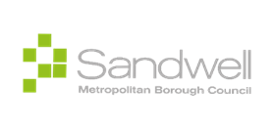

Damp, Mould and Condensation Policy Consultation Report

Contents
Aims of the consultation……………………………………….…………3
Approach to the consultation………………………………………….…3
Summary of consultation results…………………………………….......4
Consultation questions and responses…………………………...…….5
Feedback from policy engagement session…………………….....…..11
Relevant actions to be taken……………………………………….…….13

Aims of the consultation
It is vital that we hear from as many people as possible who live and work in Sandwell when shaping our policies.
This consultation has been set up to gather feedback from residents, tenants, employees and councillors on our Damp, Mould and Condensation Policy before it is finalised and published.
The policy sets out how Sandwell Council will identify, respond to, and prevent issues of damp and mould in homes. It explains the standards we are committed to, the responsibilities of both the Council and tenants, and the process for reporting and addressing concerns.
The views shared through this consultation will help shape the final version of the Damp, Mould and Condensation Policy.
Approach to the Consultation
Policy Engagement Session
The Damp, Mould and Condensation Policy was shared with residents in a policy engagement session. Residents provided feedback on the proposals of the policy, the accessibility of the document and any missing elements.
Please note that the analysis of feedback found in this report pertains only to survey feedback received in the online public consultation. The final section of this report and following table also presents feedback received from the policy engagement session with residents.
Safer Neighbourhoods and Active Communities (SNAC) Board
The policy document was shared with members of the SNAC Policy Working Group, and elected members, for additional feedback and scrutiny.
Online Consultation
Online consultation took place from 29th August to 29th September 2025. The survey included a combination of qualitative and quantitative questions, allowing respondents to provide feedback on the policy proposals and assess the document’s accessibility for residents. Based on the feedback received, revisions will be made to the policy document where necessary before it is finalised and presented to Cabinet for approval.

Summary of consultation results
The consultation findings show a mixed response to the Damp, Mould and Condensation Policy, with just over half of respondents agreeing with its aims. Supporters welcomed the council’s commitment to tackling damp and mould and protecting residents’ health, though some felt the policy was too broad and would benefit from clearer examples and more detail on how it will be put into practice.
Views were also divided on whether the policy explains clearly how damp and mould issues will be managed. While some respondents valued the overview of the council’s responsibilities, others highlighted the need for more practical guidance—such as step-by-step information on how to report problems, what action residents can expect, and within what timescales.
Most respondents felt the policy is written in a way that residents would understand, noting its structure and clear language. However, some suggested that parts could still be too complex and recommended providing additional support, such as easy-read summaries, flowcharts, or visual guides.
Overall, there was a strong sense that the policy is well intentioned, and with further refinement, it will provide a solid framework to support residents and ensure damp and mould issues are addressed effectively.
Consultation questions and responses
This policy had 11 responses.
Please tick which best describes your interest in this consultation.
6 (55%) respondents were interested in this consultation as a tenant living in socially rented accommodation.
2 (18%) respondents were interested in this consultation as a member of a voluntary or community partner organisation.
2 (18%) respondents were interested in this consultation as a private rented tenant or person living rent free.
1 (9%) respondent was interested in this consultation as a homeowner.
Please state which type of accommodation you live in.
5 (45%) respondents live in a house.
5 (45%) respondents live in a flat.
1 (9%) respondent lives in a bungalow.
Please state your age group.
4 (36%) respondents were aged 60-64.
3 (27%) respondents were aged 25-35.
3 (27%) respondents were aged 35-59.
1 (9%) respondent was aged 65 and over.
What is your gender?
7 (64%) respondents were female.
4 (36%) respondents were male.
What best describes your ethnicity?
6 (55%) respondents were English, Welsh, Scottish, Northern Irish or British.
2 (18%) respondents were White and Black Caribbean.
2 (18%) respondents were Indian.
1 (9%) respondent was Bangladeshi.
For all questions, respondents could select one of the following answers:
- Strongly agree
- Somewhat agree
- Neither agree nor disagree
- Somewhat disagree
- Strongly disagree

- Before reading this policy, I was aware of the services Sandwell Council provide in support of damp, mould and condensation.
Just over half of respondents (6 out of 11, or 55%) said they were aware of the services Sandwell Council provides to support damp, mould and condensation before reading the policy. Three respondents neither agreed nor disagreed, while two respondents strongly disagreed with the statement.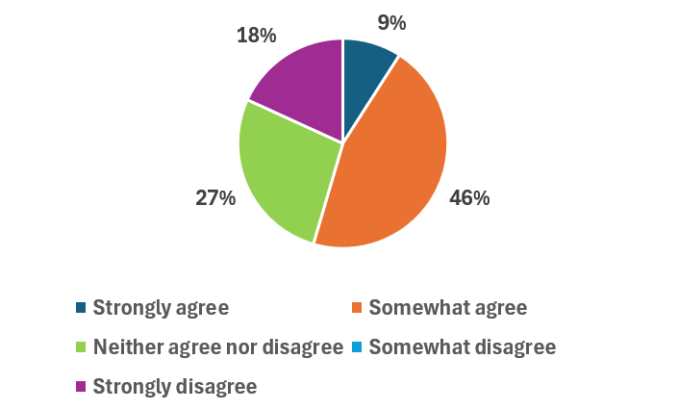
- To what extent do you agree or disagree with the purpose of the Damp, Mould and Condensation Policy?
The slight majority of respondents, 6 of 11 or 55%, agreed with the aims of the Damp, Mould and Condensation Policy.
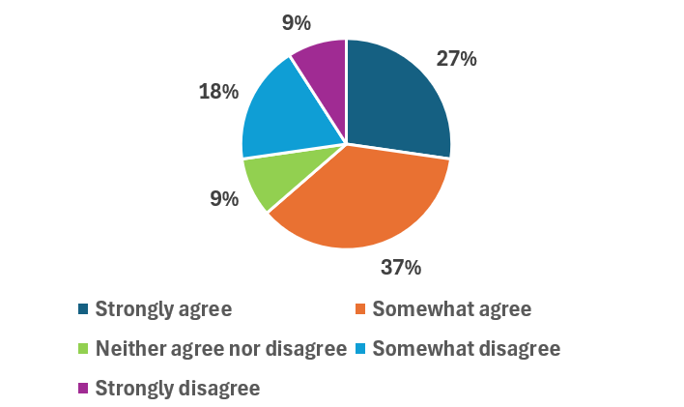
Respondents who agreed with the policy did so because they felt its aim of ensuring safe, healthy, and well-maintained homes was both important and necessary. Some welcomed the council’s commitment to tackling damp and mould, while others highlighted the importance of protecting residents’ health and wellbeing. One respondent noted that “it is important that everyone has a safe and healthy home environment.”
However, even among those who supported the policy, several felt that some of the language was too aspirational. They suggested the policy would be strengthened by clearer explanations, more practical detail, and specific examples of how cases will be managed—such as what actions the council will take and within what timescales.
Three respondents disagreed with the aims of the Damp and Mould Policy, though they did not provide reasons for their views.

- Are the damp, mould and condensation responsibilities for tenants, leaseholders and the council outlined in this policy easy to understand?
5 respondents (45%) agreed, 3 respondents (27%) disagreed and 3 respondents (27%) neither agreed nor disagreed.
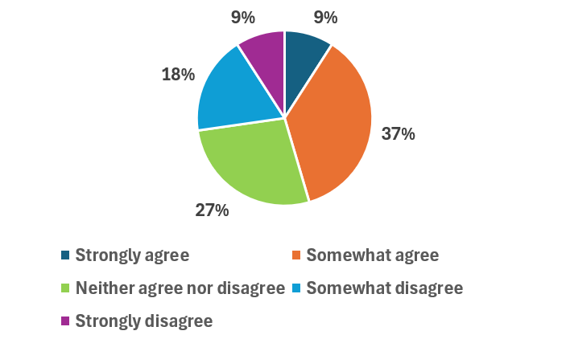
Respondents who agreed with the policy did so because they felt it clearly set out, in broad terms, the support available and the main ways the council assists residents in dealing with damp and mould.
However, those in agreement also suggested improvements. They recommended including clearer instructions on how residents can report damp and mould, what steps the council will take in response, and what residents can expect throughout the process. They also highlighted the need for more specific details—such as timescales for action, named points of contact, and escalation procedures—to give residents greater confidence that their concerns will be properly addressed.
One respondent who neither agreed nor disagreed commented that the policy “could do with a few tweaks to make it plainer.”
A respondent who disagreed explained that certain sections of the policy felt too vague about the support provided, making it difficult for residents to know what to expect. They called for more detailed information on how the council will deliver support in practice and how residents can effectively engage with the council when problems arise.

- Does the policy clearly explain how and when tenants should report damp and mould?
8 of 11 respondents (73%) agreed that the majority of residents will understand the policy. Just 1 respondent (9%) disagreed.
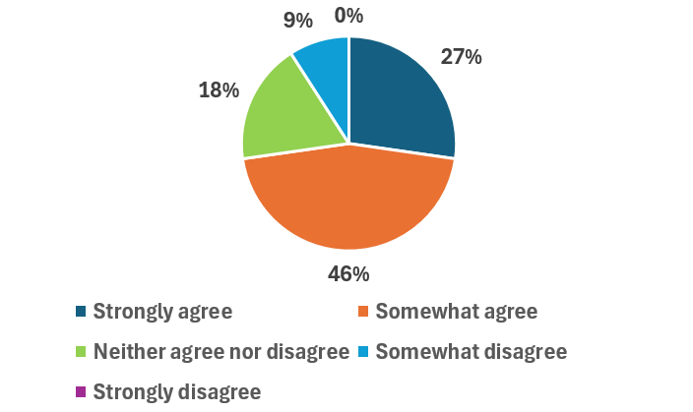

Most respondents agreed that the policy explains clearly how and when tenants should report issues of damp and mould. Eight out of eleven respondents (73%) felt the guidance was straightforward and that the majority of residents would understand it.
However, some of those who agreed also suggested ways the policy could be improved. They recommended including step-by-step instructions on the reporting process, examples of what should be treated as urgent versus non-urgent cases, and clearer information on the different reporting channels available (such as phone, online, or in person). Respondents also highlighted the value of setting out expected response times, the role of responsible officers, and escalation routes if problems are not addressed promptly.
One respondent (9%) disagreed, stating that parts of the policy remained vague and could leave residents uncertain about exactly when and how to raise concerns. Another respondent suggested that the information could be made even plainer with the use of visual aids such as flowcharts or quick reference guides.
Overall, while the majority felt the instructions were clear, there was a consistent call for more detailed, practical guidance to help residents feel confident when reporting damp and mould problems.

- Does the policy clearly outline how damp, mould, and health-related hazards will be addressed (including timescales to resolve issues)?
Most respondents felt that the policy gives a reasonable overview of how damp, mould, and health-related hazards will be dealt with, though views were mixed on the level of detail provided.
Overall, nearly three-quarters of respondents (73%) agreed to some extent that the policy outlines how these issues will be addressed, including timescales for resolution. Supporters felt reassured that the council is setting clear expectations and that the inclusion of timeframes shows commitment to accountability.
However, several respondents noted that while the policy provides a broad framework, more practical detail would strengthen it. In particular, they highlighted the need for:
- clearer timescales, especially for urgent cases affecting residents’ health;
- examples of how different types of damp and mould problems will be prioritised;
- information on which council teams or officers are responsible for responding;
- escalation routes if issues are not resolved within the expected timeframe.
One respondent who somewhat disagreed felt the timescales described were too vague, leaving residents uncertain about when action would actually be taken.
In summary, while the majority welcomed the inclusion of timescales and responsibilities, there was a consistent call for greater clarity, detail, and practical guidance to ensure residents understand exactly how their cases will be managed.
6. Any other comments
When asked for additional comments on the policy, respondents told us that:
- The policy is well-organised and written in clear, straightforward language, making it accessible for most residents to understand their rights and the support available.
- The intentions of the policy are commendable, and with ongoing refinement, it has the potential to better meet residents’ needs.
- While the language and structure are generally clear, occasional use of jargon or complex sentences could be simplified to ensure all residents can fully understand the content.
- Respondents welcomed the council’s efforts to clarify reasonable adjustments, noting that regular review will help maintain clarity and accessibility for everyone.

Feedback from policy engagement session
The feedback presented below was provided by residents of Sandwell in a policy engagement session.
1. Awareness of the policy
- Awareness among residents was mixed; some were familiar with the Council’s approach to managing damp, mould, and condensation, while others were not.
- Those who were aware often had personal experience or knew someone affected by these issues.
- Residents highlighted the importance of raising awareness through local channels such as the Sandwell Herald, communal noticeboards, libraries, and other community spaces.
- Some residents asked how much influence they have over policy updates or changes.
2. Clarity of support provided by the policy
- The policy outlines general intentions but lacks detail on how support is provided in practice.
- Residents raised questions about how reports are handled, outcomes tracked, and communications delivered.
- Broader promotion of the policy is needed to ensure residents can access the information easily.
- Suggestions included:
  - Adding a tile or notification on the MySandwell dashboard.
  - Using infographics to improve visibility and understanding.
  - Strengthening partnerships with housing officers and specialist support services to streamline response.
  - Holding regular drop-in sessions to increase engagement with residents.
- Terms like “reasonable” or “timely” were seen as too vague; residents suggested providing clearer definitions.
- Examples of steps taken to address damp, mould, and condensation should be grouped in a clear, easy-to-read format using simple language.
3. Information gaps in the policy
- Most residents felt the core information is present, but improvements in clarity and accessibility are needed.
- Inclusion of real-life examples of interventions would help, particularly for households with vulnerable occupants, underlying health conditions, or barriers such as language, sensory impairments, or isolation.
- The policy’s language is currently too technical and should be simplified to ensure understanding by all residents.
- Further promotion could be carried out via WhatsApp groups, local newsletters, noticeboards, and councillor or MP surgeries.
- Infographics and digital enhancements, including a MySandwell tile, could help meet diverse accessibility needs.

Actions taken in response to consultation feedback
During the consultation, respondents were given the opportunity to elaborate on the reasoning behind their answers to the multiple choice questions. Question 5 also asked for any additional feedback on the policy not otherwise stated. Feedback received from respondents can be found in the table below, in addition to our response and any actions we are taking.

What respondents told us |  | Our Response | Relevant Actions | Timescale
 | While the policy outlines broad intentions, it lacks specific guidance on how cases of damp, mould, and condensation are handled in practice, including timelines and responsible contacts. | Sandwell Council acknowledges the need for clearer operational guidance and commits to making the policy more actionable. | Establish and communicate a clear process for responding to reports of damp, mould, and condensation, specifying implementation timelines and identifying responsible contacts. | October 2025
 | To raise awareness of the policy, it could be promoted on the Sandwell Herald, local noticeboards, libraries, community spaces, WhatsApp groups, and council surgeries. | The Council agrees that broader promotion is essential to improve accessibility and awareness. | Develop and implement a communications plan using recommended local and digital channels, incorporating resident engagement as part of the Tenant Engagement Strategy to be produced later this year. | December 2025
 | Visual tools, infographics, and guides could make the policy more accessible and reader-friendly. Plain English should always be used. | The Council will revise the policy using plain English and develop supporting visual materials. | Commission or develop infographics and Easy Read versions of the policy. Conduct a plain English review. | October 2025
 | Examples of what actions or interventions might be taken could be included in the policy. | Including real-world examples will make the policy more practical and relatable. | Add a section with case studies and example scenarios demonstrating how damp, mould, and condensation issues are addressed. | October 2025
 | Terms such as “reasonable” or “timely” are open to interpretation. Clearer definitions could be provided. | We recognise this ambiguity and will provide clearer definitions aligned with legal guidance and practical considerations. | Define key terms with reference to best practice and operational standards. | October 2025

